To the Graduate Council:

I am submitting herewith a thesis written by David Albert Thigpen entitled “The Theory Behind Magazine Business Decisions.” I have examined the final copy of this thesis for form and content and recommend that it be accepted in partial fulfillment of the requirements for the degree of Master of Arts, with a major in Journalism.

______________________________
Dr. Samir A. Husni, Professor of
Journalism and Hederman Lecturer

We have read this thesis
and recommend its acceptance:

_____________________________________
Dr. Samir A. Husni, Professor of Journalism and Hederman Lecturer

_____________________________________
Dr. Kathleen Wickham, Associate Professor of Journalism

_____________________________________
Dr. William Shughart, F. A. P. Barnard Distinguished Professor of Economics

Accepted for the Council:

____________________________
Dean of the Graduate School

STATEMENT OF PERMISSION TO USE

In presenting this thesis in partial fulfillment of the requirements for a Master’s degree at The University of Mississippi, I agree that the Library shall make it available to borrowers under rules of the Library. Brief quotations from this thesis are allowable without special permission, provided that accurate acknowledgment of the source is made.
Permission for extensive quotation from or reproduction of this thesis may be granted by my major professor or in his absence, by the Head of Interlibrary Services when, in the opinion of either, the proposed use of the material is for scholarly purposes. Any copying or use of the material in this thesis for financial gain shall not be allowed without my written permission.

Signature____________________________
Date________________________________
The Theory Behind Magazine Business Decisions

A Thesis
Presented for the
Master of Arts
Degree
The University of Mississippi

David Albert Thigpen
October 2010
Copyright © 2010 by David Albert Thigpen
All rights reserved

DEDICATION

This work is dedicated to my parents.
They’ve given a lot so that my brothers and I could succeed,
and have always pushed me to excel in all of my work.

ACKNOWLEDGMENTS

I would like to thank all of the people who have in some way influenced the direction of parts of this document. Specifically, the central theme of this document paper is based on a blog posting by Dr. Samir Husni. He often talks about how magazines are charging too little for their product. After hearing that the past couple of years, I decided that I wanted to see if there was a way to statistically say anything about whether or not magazines really are charging enough for their product.
I would like to thank Dr. Kathleen Wickham for her suggestions about several of the citations, research questions and other helpful advice. I would also like to thank Dr. William Shughart for his suggestions with regard to some of the wordings that I used and with regard to the introduction to the paper.
Also, when I was doing the modeling at the end of chapter three, I benefited from Dr. John Conlon letting me know if I was on the right track. There was also a time when my intuition was jogged by homework problems and lecture notes in Dr. Mark Van Boening’s class. This helped me do a better job of organizing the explanation in chapter two. There are also other reasons I should to thank him. In addition to the things I have learned in his class, Dr. Van Boening played a minor role in my ever taking a graduate economics class. When he was chair and was filling out my graduation application for undergrad, he was the first person to suggest that I should consider going to graduate school in economics based on a lot of the math on my transcripts. At the time, all of my funding was tied to the computer science department, but he planted the seed in my head. My Mom kept the thought alive and encouraged me to try the classes out. Those classes ended up being extremely useful during the writing of this paper.
ABSTRACT

This thesis looks at the print magazine industry as a whole. It seeks to determine whether or not magazines are charging enough for their content. It also looks at the impact of income on a consumer’s decision to buy a magazine. It seeks to find out whether the market for magazine advertising is a competitive market, and studies the responsiveness of magazines to a change in ad rates. Along the way, some attention will be paid to properly setting up the measurement of relative elasticities. Specifically, whether or not the own-price elasticity of demand or the income elasticity of demand can be measured for any free form of media. Also, some comments will be made about the independent variables needed in the regression model to measure the income elasticity of a free good and whether or not those variables are easily measurable.

TABLE OF CONTENTS

CHAPTER PAGE
I. INTRODUCTION 1

II. A FRAMEWORK FOR ANALYSIS 3

III. NECESSARY MATH 24

SECTION I. UNCONSTRAINED OPTIMIZATION (SORT OF) 24

SECTION II. OPTIMIZING UNDER CONSTRAINTS 30

IV. REVIEW OF LITERATURE 57

V. STATISTICAL ANALYSIS 66

SECTION I. DATA PROVENANCE 66

SECTION II. REGRESSIONS AND ANALYSIS 67

VI. CONCLUSION 74

WORKS CITED 77

VITA 85

LIST OF FIGURES

FIGURE PAGE
Marginal Revenue and Elasticity Along the Demand Curve 4

The intersection of Marginal Cost with Marginal Revenue and Elasticity 6

Profit and Dead Weight Loss 7

Competitive Markets Where the Producer Maintains Elasticity 9

Competitive Markets and Perfectly Elastic Demand 10

Consumer Theory and the Indifference Curve 12

The Income Effect for Two Normal Goods 14

The Income Effect for One Normal Good (Vertical Axis) and One Inferior Good(Horizontal Axis) 14

The Income Effect for One Normal Good (Horizontal Axis) and One Inferior Good (Vertical Axis) 15

The Substitution Effect 16

The Income Effect and Substitution Effect for Two Normal Goods 17

The Income Effect and Substitution Effect for One Normal Good (Vertical Axis) and One Inferior Good
(Horizontal Axis) 18

The Income Effect and Substitution Effect for One Normal Good (Horizontal Axis) and One Inferior Good (Vertical Axis) 18

An Introduction To the Consumption-Leisure Model 20

A Large Substitution Effect Versus a Small Income Effect in the Consumption-Leisure Model 21

A Large Substitution Effect and a Large Income Effect in the Consumption-Leisure Model 21

Chart of income versus Circulation 75

LIST OF TABLES

TABLE PAGE
Regression Statistics Table for ln(circulation)= b₁ln(price)+ b₂ln(income) +b₀ on the combine dataset 68

Anova Table for ln(circulation)= b₁ln(price)+ b₂ln(income) +b₀ on the combine dataset 68

Variable Results Table for ln(circulation)= b₁ln(price)+ b₂ln(income) +b₀ on the combine dataset 68

Regression Statistics Table for ln(circulation)= b₁ln(price)+b₀ on the combine dataset 69

Anova Table for ln(circulation)= b₁ln(price)+b₀ on the combine dataset 69

Variable Results Table for ln(circulation)= b₁ln(price)+b₀ on the combine dataset 69

Regression Statistics Table for ln(circulation)= b₁ln(price)+b₀ on the Publisher’s Information Bureau dataset 70

Anova Table for ln(circulation)= b₁ln(price)+b₀ on the Publisher’s Information Bureau dataset 70

Variable Results Table for ln(circulation)= b₁ln(price)+b₀ on the Publisher’s Information Bureau dataset 70

Regression Statistics Table for ln(ad rate)= b₂ln(circulation)+b₀ on the Publisher’s Information Bureau dataset 71

Anova Table for ln(ad rate)= b₂ln(circulation)+b₀ on the Publisher’s Information Bureau dataset 71

Variable Results Table for ln(ad rate)= b₂ln(circulation)+b₀ on the Publisher’s Information Bureau dataset 71

Regression Statistics Table for ln(ad pages)= b₃ln(ad rate)+b₀ on the Publisher’s Information Bureau dataset 72

Anova Table for ln(ad pages)= b₃ln(ad rate)+b₀ on the Publisher’s Information Bureau dataset 72

Variable Results Table for ln(ad pages)= b₃ln(ad rate)+b₀ on the Publisher’s Information Bureau dataset 72

CHAPTER I
INTRODUCTION

This thesis aims to measure the price elasticity of demand and the income elasticity of demand for magazines as well as the price elasticity of supply of magazine advertising. Using the results, this thesis will try to answer the following research questions in the conclusion.
RQ₁: Can it be said definitively that magazines are not charging enough for their content?
RQ₂: Does income impact a consumer’s decision to buy a magazine?
RQ₃: If the answer to RQ₂ is yes, are magazines inferior or normal goods?
RQ₄: Is the market for magazine advertising a competitive market?
RQ₅: If the answer to RQ₄ is yes, how responsive are magazines to a change in ad rates?
RQ₆: If the answer to RQ₄ is no, can it be said definitively that magazines are not charging enough for advertising?
While elasticities - the percentage change in one variable associated with the percentage change in another variable - are normally considered to be confined to the area of economics, there is a growing body of literature in journalism and communication that deals with calculating elasticities for various media and publications. This literature covers almost every type of media, but magazines. In some cases, the research is done well, but, in other cases, people are mistaken about what exactly it is that they are measuring, which leads to erroneous results. This is why it is important to lay out a solid framework for what exactly is being measured, so that erroneous conclusions aren’t made based on the results of the statistical analysis. As a result, this thesis will seek to answer the following research questions in constructing the model, and it will restate the answers in the conclusion.
RQ₇: Can the elasticity of demand be measured for a free good?
RQ₈: Can the income elasticity be measured for a free good?
RQ₉: If the answer to RQ₈ is yes, what are the considerations that need to be made to be able to measure the income elasticity of a free good and are these considerations easily measurable?
With this in mind, the second chapter will lay out the framework for analyzing the data and will attempt to use as little math as possible. Most of the math used is going to be in the realm of basic algebra. The third chapter will give a more rigorous mathematical background to everything that is stated in the second chapter. It will mainly use matrix algebra and calculus. The fourth chapter will review some of the existing literature on other media. The fifth chapter will look at the results of the statistical analysis and the sixth chapter will present conclusions.
CHAPTER II
A FRAMEWORK FOR ANALYSIS

The analysis in this paper will mainly be based off of the price elasticity of demand, the income elasticity of demand, the cross-price elasticity of substitution and the price elasticity of supply. Each of these elasticities will be introduced in turn.
From McCloskey (1982), it is known that the price elasticity of demand represents the impact that a change in price has on total sales of a given product at a given period of time, or the consumer’s sensitivity to changes in price. It is represented by the function E_{d}=((x₁-x₀)/ x₀)/((p₁-p₀)/ p₀) with x₁ and x₀ representing the quantity of good x at two different points in time and p₁ and p₀ representing the price of good x at two different points in time. Goods are labeled elastic if E_{d}<-1, goods are labeled unit elastic if E_{d}=-1, goods are labeled inelastic if E_{d}>-1 and E_{d}<=0, and goods are considered to be Giffen goods if E_{d}>0.
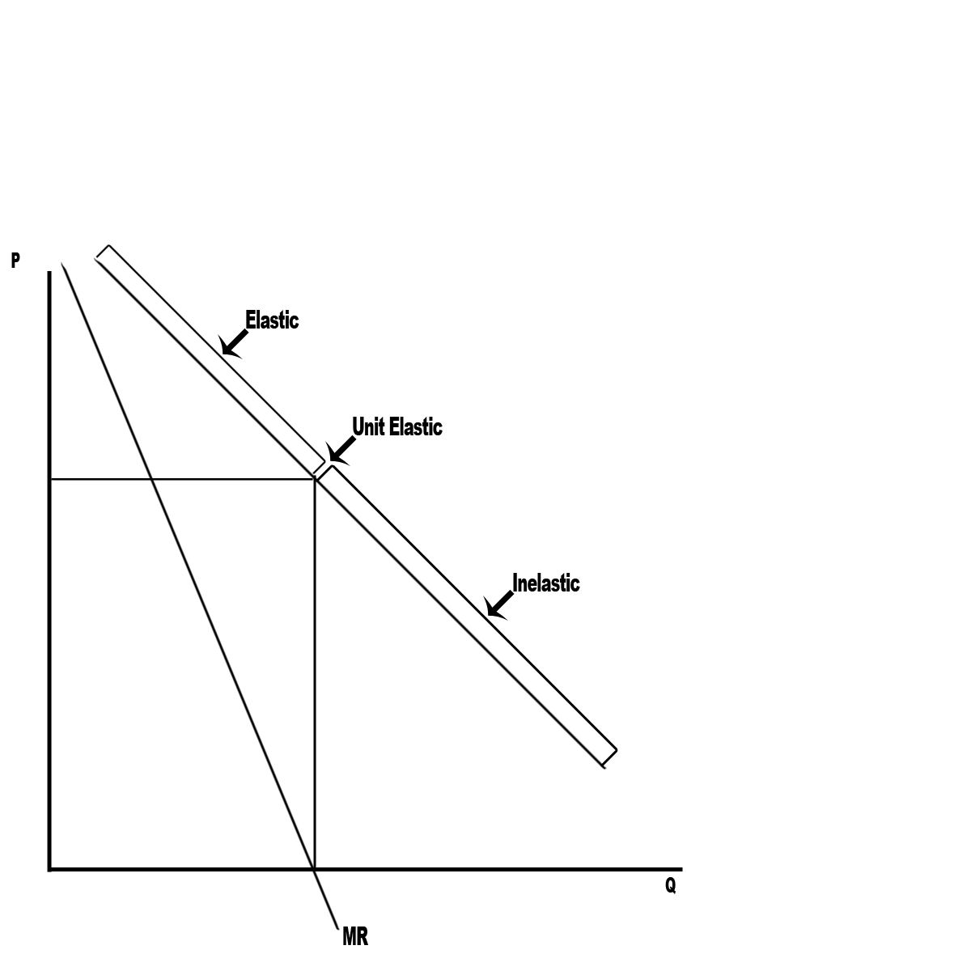
Figure 1
Based on the definitions in McCloskey (1982), Figure 1 shows the relationship between a straight-line market demand curve and whether or not the demand for a good is elastic, unit elastic or inelastic. The answer depends on whether or not marginal revenue is positive, equal to zero or negative at a given quantity and price on the demand curve.
By the definition in McCloskey (1982), if a good is inelastic, then an increase in price results in an increase in total revenue and a decrease in total costs from the sale of fewer goods. Thus, holding all other things constant, if the demand for a good is inelastic, an increase in price will result in an increase in profit for the seller of the good.
By the definition in McCloskey (1982), if a good is elastic, then an increase in price results in a decrease in total revenue and a decrease in total costs from the sale of fewer goods. A profit-maximizing firm would continue to increase prices until the cost of producing an additional unit of a good equals the revenue generated from that good.
By the definition in McCloskey (1982), if a good is a Giffen good, then an in crease in the price results in an increase in the quantity sold and an increase in total revenue. Also, a decrease in the price results in a decrease in the quantity sold and a decrease in total revenue. This would also mean that the demand curve would be upward sloping, since quantity demanded would rise with price.
From McCloskey (1982), while there are some areas in between, there are two different extremes, which a producer could face - monopoly and perfect competition. By the definition in McCloskey (1982), if a producer is a monopolist, has pricing power and is a profit-maximizing firm, it would be expected to price its product in the elastic range of demand, because if the product were priced in the inelastic range, the firm could raise the price further and increase profit.
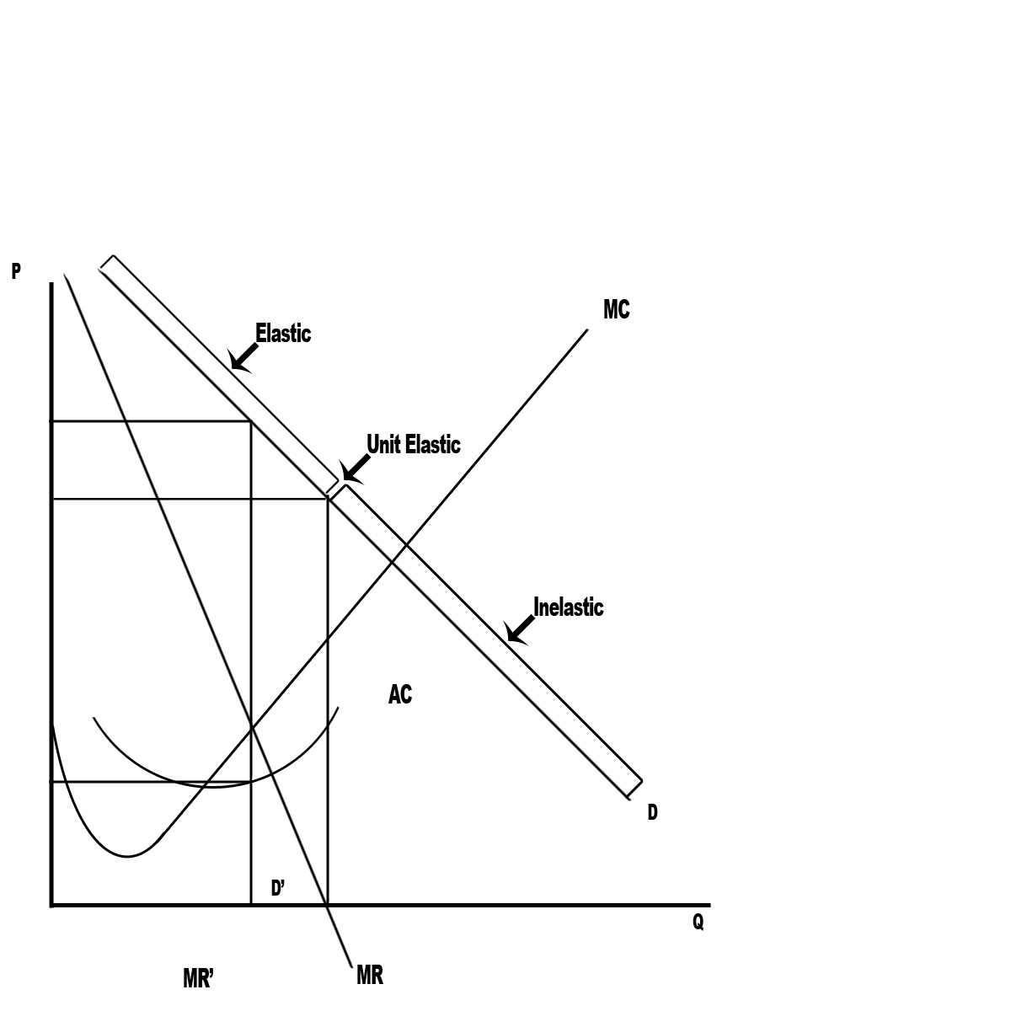
Figure 2

Based on the definitions in McCloskey (1982), figure 2 shows an example where the producer is a monopolist. Notice that the quantity is determined by the intersection of the marginal cost curve and the marginal revenue curve, where the cost of producing the last unit equals the additional revenue from selling that unit. But the product is priced relative to the point on the demand curve that is at the particular quantity supplied, which is on the elastic part of the demand curve.

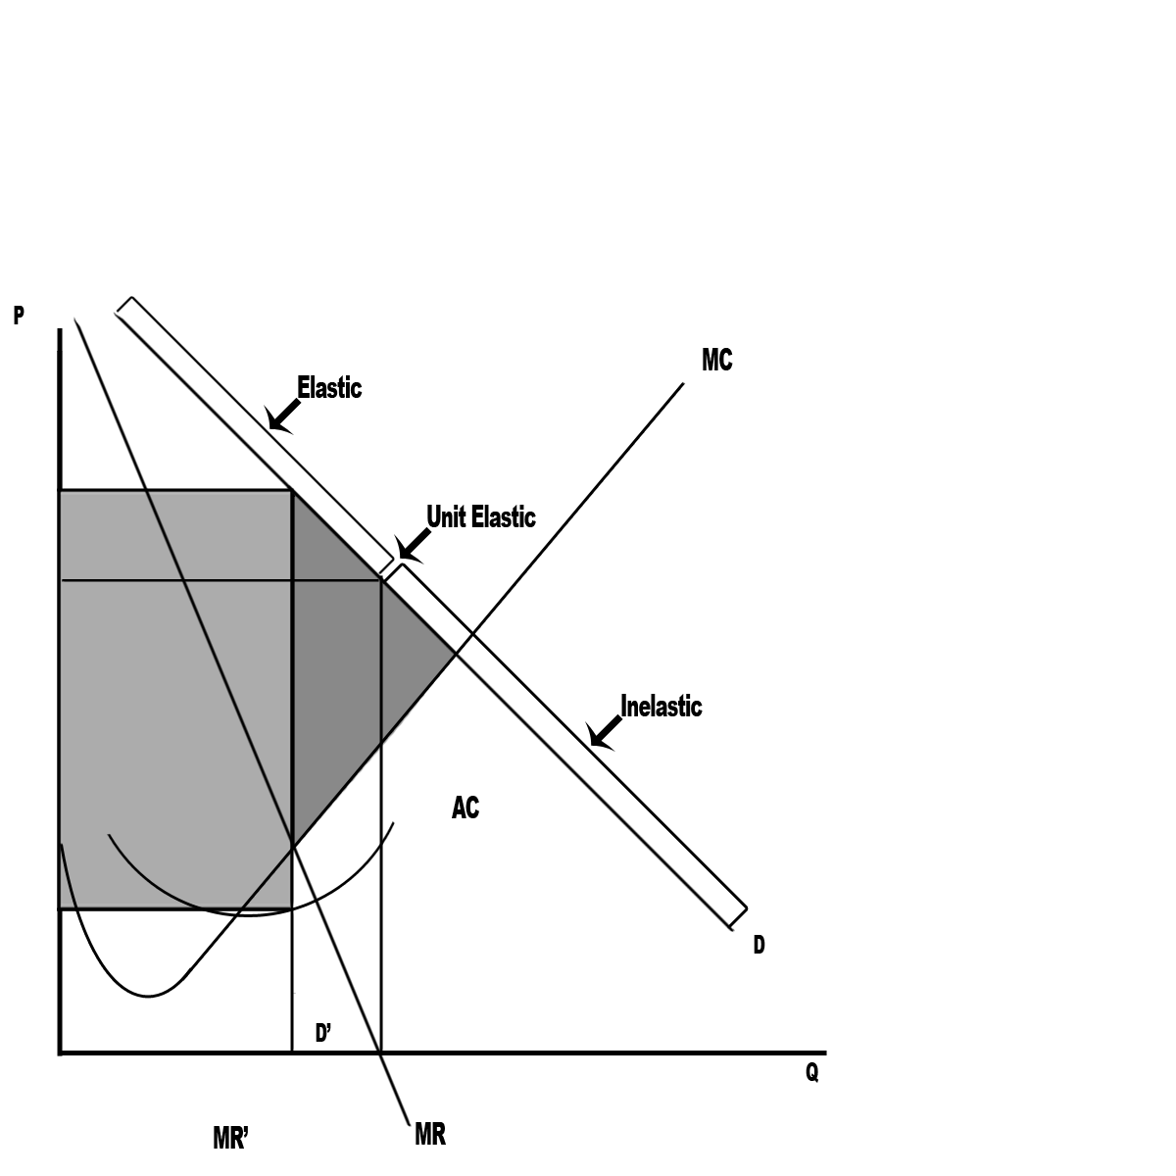
Figure 3

Figure 3 is based on the definitions in McCloskey (1982). The lighter shaded area represents the profit that a monopolist makes if it charges the monopoly price. The upper part of the rectangle representing profit is price and the lower part of the rectangle is represented by the average cost at that particular quantity sold. Notice that, by charging the monopolist price, the producer is throwing away some potential profit, which is represented by the darker shaded area and is often referred to as dead-weight loss. Some producers try to get some of this dead-weight loss back through special pricing schemes aimed at new customers.
Not all producers are alone in the marketplace. From McCloskey (1982), as the number of producers rises and the market moves towards perfect competition, there are two possibilities as to what will happen in the long run. In the first case, the producer has a product that can be differentiated from other sellers of similar goods. In this case, the producer may spend money on marketing to advertise this difference and make product demand less elastic by attempting to create some brand loyalty. In the long run, the result is that the demand curve maintains its slope and shifts in until it is tangent to the average cost curve, which means that the producer makes no profit from the sale of the good and sells fewer of the products. In the second case, the demand for the good becomes perfectly elastic. In this case, the demand curve becomes flat and is tangent to the average cost curve at the lowest point on the average cost curve. The producer makes no profit in this case as well.
From McCloskey (1982), this does not mean that firms in competitive markets will never make a profit. In the short run firms may make a profit, but the long run picture shows that any profit that producers are able to make will eventually be eaten into by the entry of new producers, except in the case of high barriers to entry, government sanctioned monopolies or heavily regulated industry.
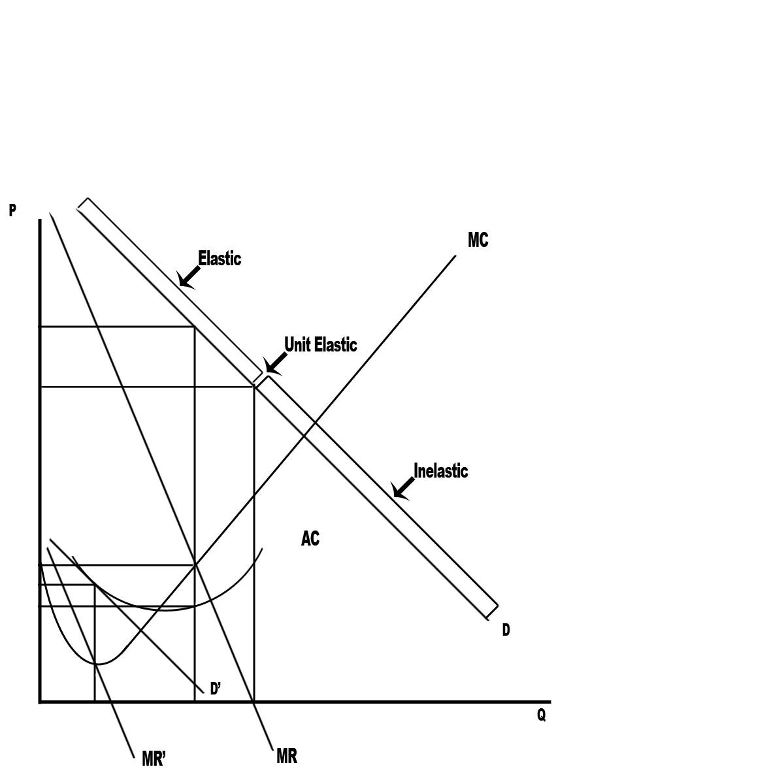
Figure 4

Based on the definitions in McCloskey (1982), Figure 4 is an example of what happens when the good is sufficiently differentiable from the other goods in the marketplace. The demand curve labeled D and the marginal revenue curve labeled MR are the original curves. The demand and the marginal revenue curves shift in to the curves labeled D’ and MR’ respectively. In the long run, the producer makes no money, because long run average cost is equal to the price of the good.
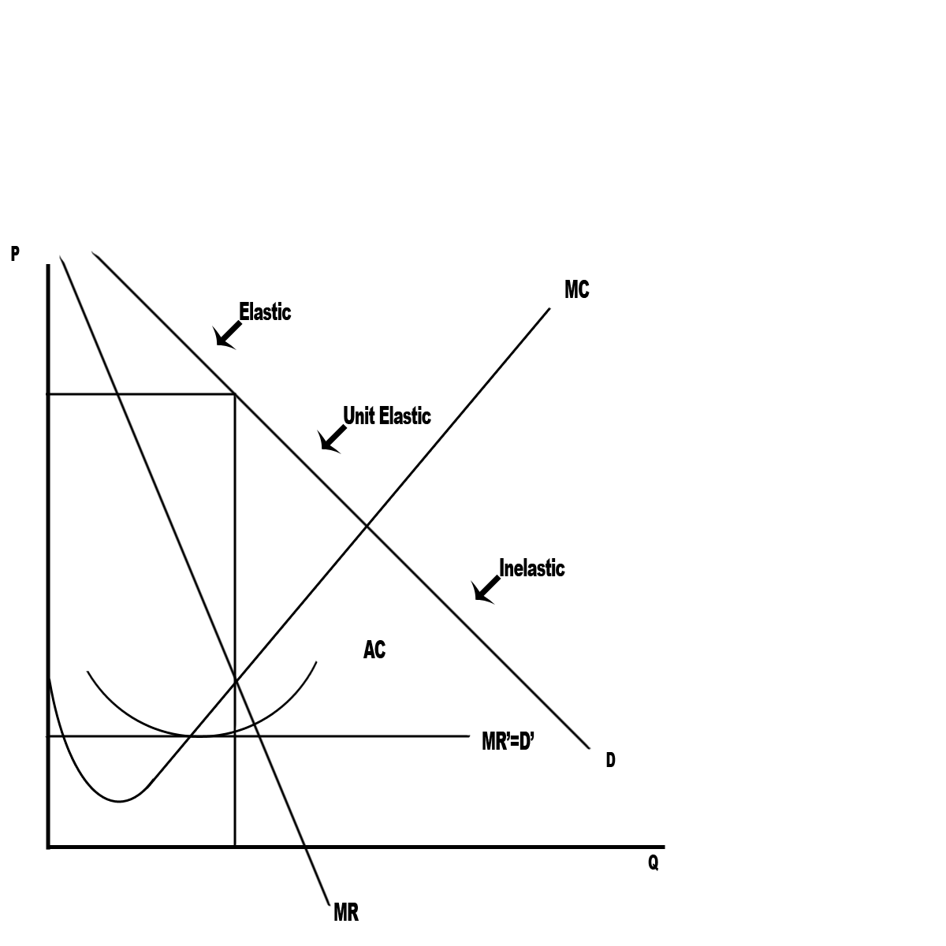
Figure 5

Figure 5 is based on the definitions in McCloskey (1982). The producer’s good cannot be differentiated from those of the new entrants. The demand curve labeled D and the marginal revenue curve labeled MR are the original curves. In the long run, the demand curve flattens out such that marginal revenue equals demand, which also equals the market price of the good. The new demand and the marginal revenue curves for this case are labeled D’=MR’. In the long run, the producer breaks even, because long run average cost is equal to the price of the good.
An interesting thing about the second case where the market demand curve becomes perfectly elastic or flat is that the price sensitivity is no longer attributabe to the consumer. This has the result that the measurement of the percentage change in quantity sold over the percentage change in price is actually the price elasticity of supply for that good, because you are actually measuring the producer’s sensitivity to changes in price.
From McCloskey (1982), the price elasticity of supply is defined as E_{supply}=((x₁-x₀)/ x₀)/((p₁-p₀)/ p₀) with x₁ and x₀ representing the quantity of good x at two different points in time and p₁ and p₀ representing the price of good x at two different points in time. Goods are labeled elastic if E_{supply}>1, goods are labeled unit elastic if E_{supply}=1, and goods are labeled inelastic if E_{supply}<1 and E_{supply}>=0. The elasticity of supply is always positive, because a profit-maximizing firm will always price its product at the point where the marginal cost curve intersects with marginal revenue on the upward sloping segment of the marginal cost curve. Otherwise, the firm is leaving some profit on the table. The slope of the marginal cost curve is important, because it determines the sign of the elasticity of supply, because the supply curve from which the elasticities are measured is the horizontal sum of the marginal cost curves of all of the producers. The size of the elasticity of supply mainly depends on the producer’s ability to increase supply.
A general rule will be used to determine whether the price elasticity of supply or the price elasticity of demand is being measured. If it can be shown that the producer has no control over the price that it charges, then a flat demand curve will be assumed, and it will be assumed that measured price sensitivity is on the part of the producer. Otherwise, the demand curve will be assumed to be downward sloping and measured price sensitivity will be assumed to be determined by the behavior of consumers.
In looking at demand in the previous depictions, you may have noticed by now that it is almost always sloping downward. There is an intuitive argument for why this is the case. If you hold people’s utility constant, as the price of one good rises, consumers substitute out of that good and into other goods. This effect is called the substitution effect. For almost all goods, this effect has the biggest impact on the slope of the demand curve. But there is another effect that sometimes moderates and sometimes reinforces the impact of the substitution effect on demand. This effect is called the income effect. It covers what happens when income increases and prices are held constant. A similar description of this can be found in McCloskey (1982).

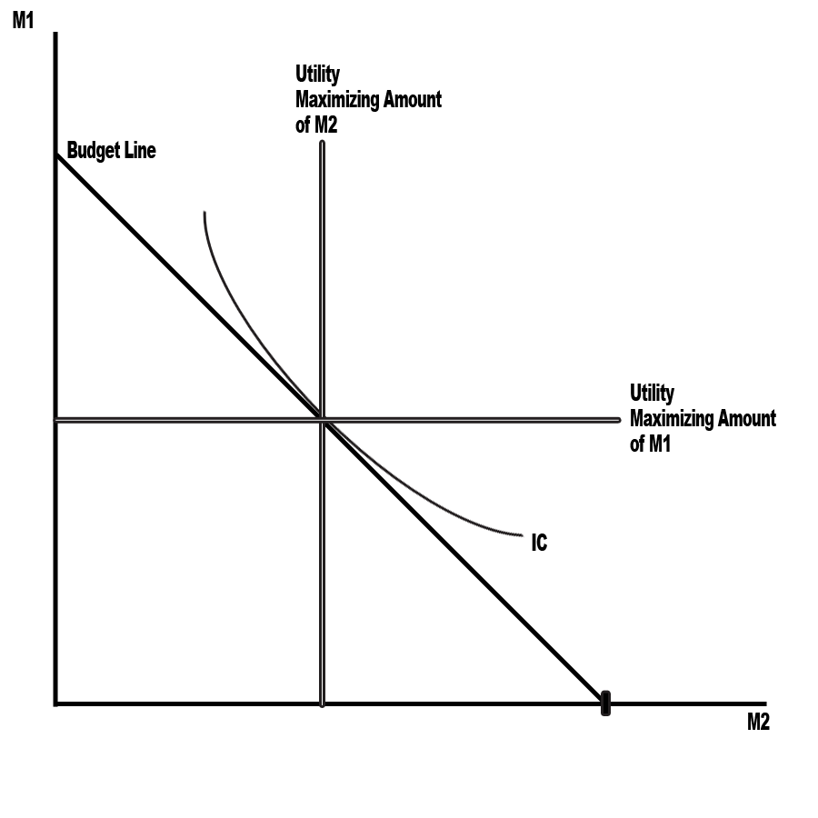
Figure 6

Based on the definitions in McCloskey (1982), Figure 6 shows the graphical representation used to identify the income and substitution effects. The budget line represents all of the possible combinations of good one and good two that can be purchased at a given income. The indifference curve represents a set of combinations of good one and good two to which the consumer would be indifferent, where every combination on the indifference curve has the same utility to the consumer. The tangency represents the optimal bundle of good one and good two for that particular utility curve.
From McCloskey (1982), the income effect has two components to it. It is influenced by the percentage of your income that you spend on a given good and whether or not you will buy more of that good as your income rises. This last thing is known as the income elasticity of demand. The income elasticity of demand is represented by the following function E_{I}=((x₁-x₀)/ x₀)/((I₁-I₀)/ I₀) with x₁ and x₀ representing the quantity of good x at two different points in time and I₁ and I₀ representing the a consumer’s income at two different points in time.
Based on the income elasticity of demand, goods can be categorized as normal or inferior goods. A good is a normal good if the income elasticity of demand is greater than 0, because the consumption of the good increases with income. A good is an inferior good if the income elasticity of demand is less than 0, because the consumption of the good falls with increases in income. It is important to remember that the income effect exists as a result of the fact that income serves as a constraint on the consumer’s ability to purchase goods.
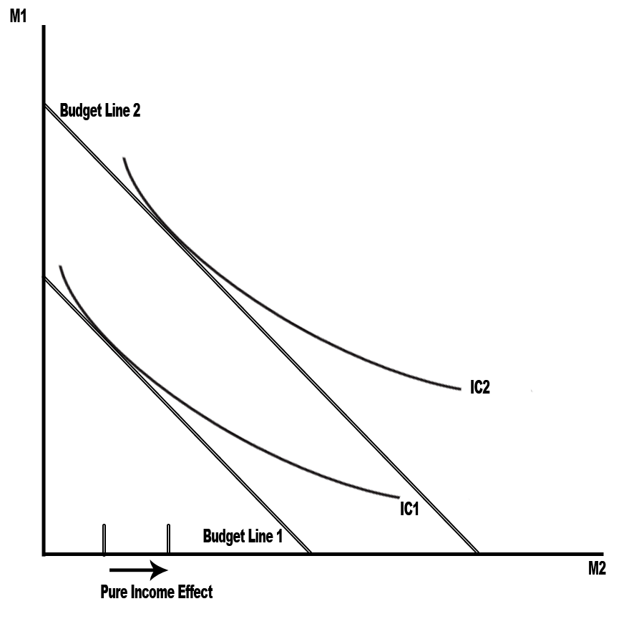
Figure 7

Based on the definitions in McCloskey (1982), Figure 7 is an example of what the income effect looks like for two normal goods, because demand rises for good one and good two as income rises.

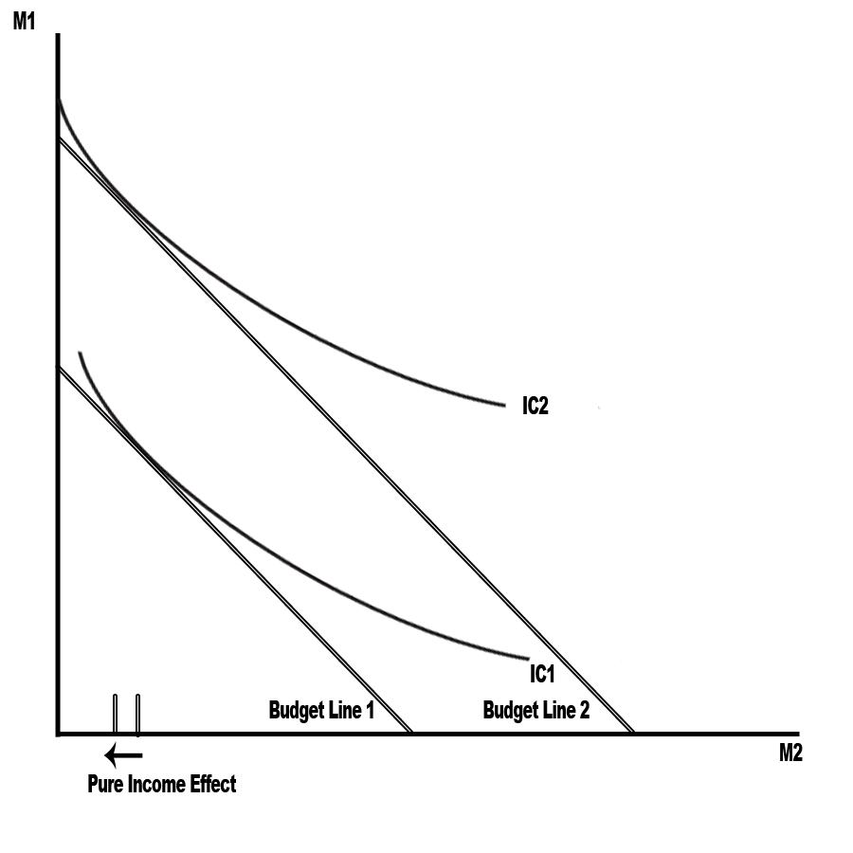
Figure 8

Based on the definitions in McCloskey (1982), Figure 8 is what it looks like if the good on the horizontal axis is inferior and the good on the vertical axis is normal, because demand for good two falls as income rises and demand for good one rises as income rises.

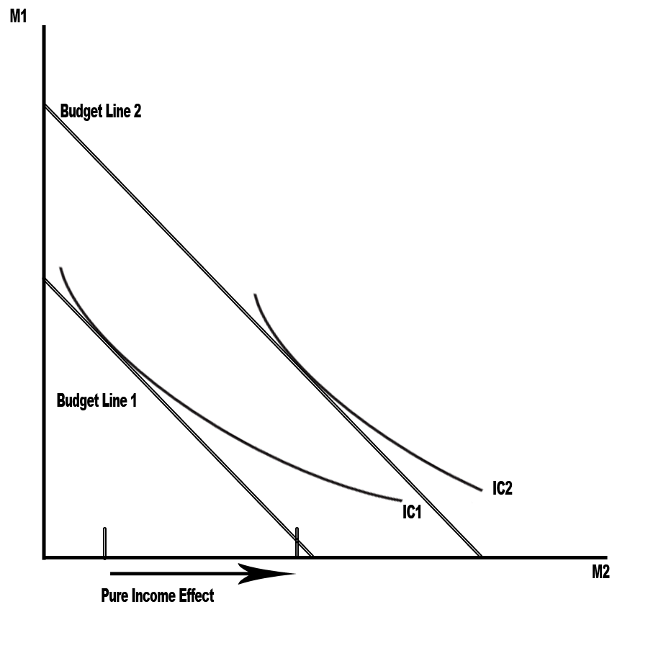
Figure 9

Based on the definitions in McCloskey (1982), Figure 9 is what it looks like if the good on the vertical axis is inferior and the good on the horizontal axis is normal, because demand for good one falls as income rises and demand for good two rises as income rises.
From McCloskey (1982), the substitution effect measures the impact that the change in the price of one good relative to the price of other goods has on the relative quantity demanded for the good that increased in relative price. This effect is often measured through the elasticity of substitution. The elasticity of substitution is represented by the following function E_{s}=((x₁/ y₁-x₀/ y₀)/(x₀/ y₀))/ ((p₁/ q₁-p₀/ q₀)/(p₀/ q₀)) with x₁ and x₀ representing the quantity of good x at two different points in time, y₁ and y₀ representing the quantity of good y at two different points in time, p₁ and p₀ representing the price of good x at two different points in time, and q₁ and q₀ representing the price of good y at two different points in time. It is important to remember that the utility level being fixed and the change in relative price is what causes the substitution out of one good and into another.

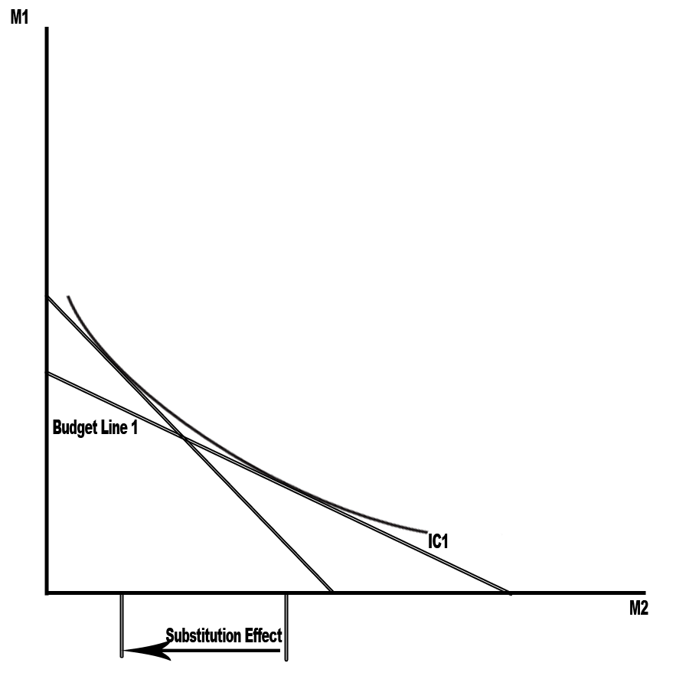
Figure 10

Based on the definitions in McCloskey (1982), Figure 10 is a graphical representation of the substitution effect. Notice how the substitution effect moves along the indifference curve. That is because the elasticity of substitution is a measure of the curvature of the indifference curve. Remember, the utility level has not changed in the movement along the curve.
From McCloskey (1982), the elasticity of substitution and the elasticity of income satisfy an identity called the Slutsky equation that relates them directly to the price elasticity of demand. It is the following function E_{d}= E_{s}+sE_{I} with s representing the share of the consumers income endowment that the good takes up.
The share that a good has of a person’s income can be very important, especially for Giffen goods. Producers of Giffen goods can raise the price of their good and still sell more of it. For a good to be a Giffen good, a good has to be an inferior good that takes up a large portion of a person’s income and has very few substitutes. There isn’t any recorded instance of it ever happening. But if this could happen in real life, the producer could be a virtual alchemist, so income share has a big impact on pricing.
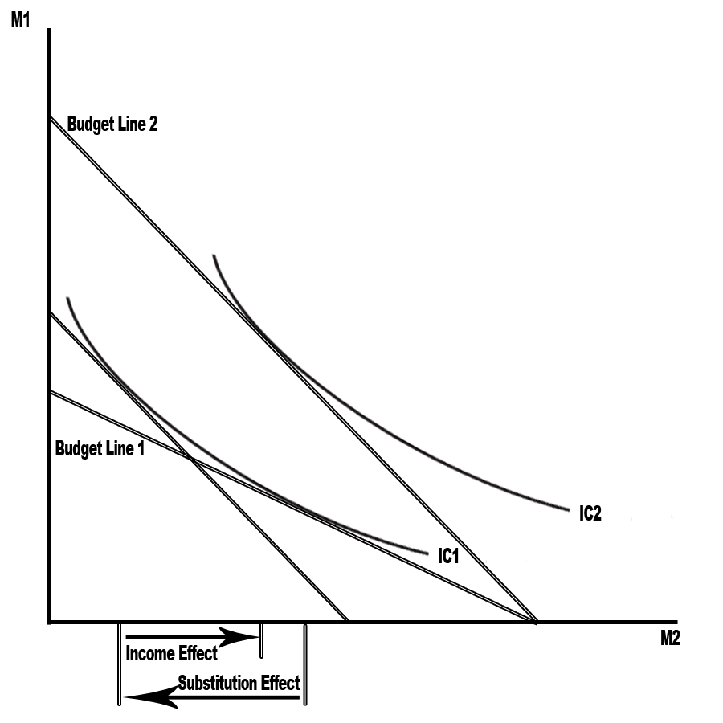
Figure 11

Based on the definitions in McCloskey (1982), Figure 11 is a graphical representation of the income and the substitution effect with two normal goods.
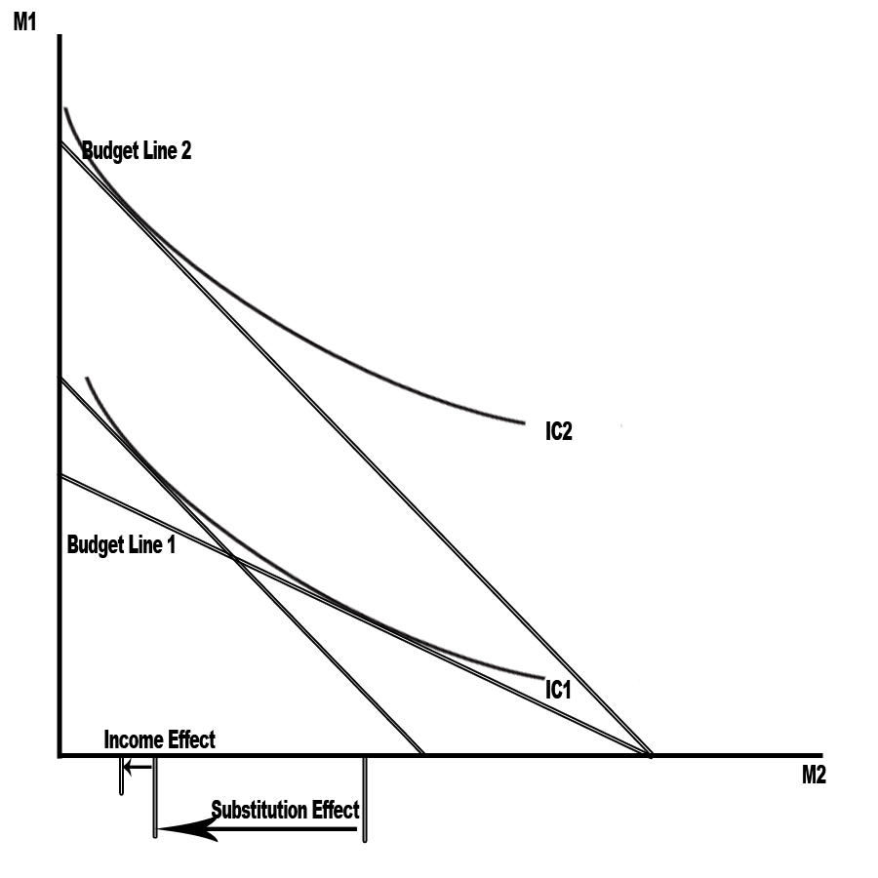
Figure 12

Based on the definitions in McCloskey (1982), Figure 12 is a graphical representation of the income and the substitution effect with an inferior good on the horizontal axis.

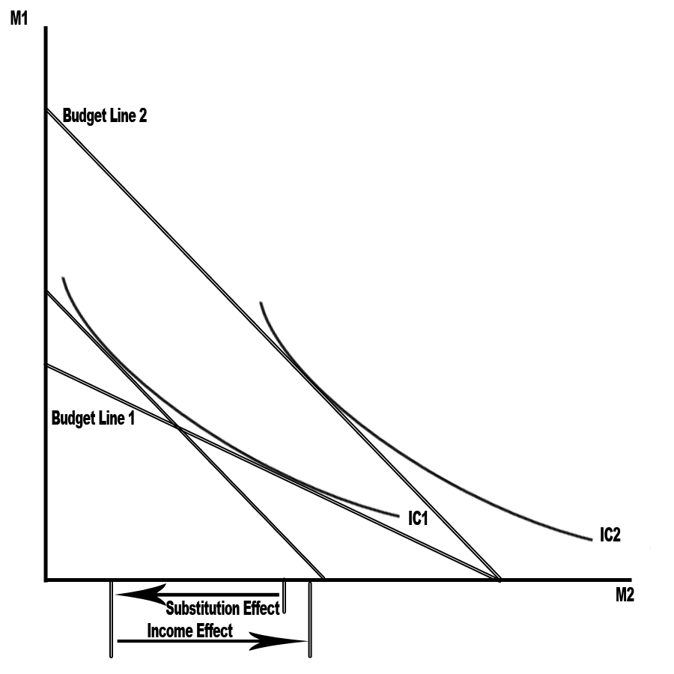
Figure 13

Based on the definitions in McCloskey (1982), Figure 13 is a graphical representation of the income and the substitution effect with an inferior good on the vertical axis.
It is important to remember that the income effect is the change in quantity demanded, when income changes and relative prices are held constant, and that the substitution effect is the change in quantity demanded, when relative prices change and utility is held constant.
This restriction on the definition of the income and substitution effect has not stopped some in the media industry from trying to make some strange assertions about whether or not a particular type of media provided for free was a normal or inferior good based on the amount of time that people spent with the media in relation to their monetary income. These people try to define types of media that see an increase in time spent with them when people’s income rises as normal goods, and define types of media that see a decrease in time spent with them when people’s income rise as inferior goods. This is most often used to try to measure income elasticity for free forms of media like the Internet or free newspapers, because income is not a constraint on the consumption of a free good. The only constraint on people’s consumption of a free good is time, but time is money and so time could be a rough proxy for the opportunity cost of consuming free media, which itself depends on income.
One good example of measuring time spent with a medium versus income to find the income elasticity is a paper by Hsiang (2009), which used the change in time spent with media versus the change in income as a way of defining online news as an inferior good. One problem with defining inferior and normal goods in this way is that, when you measure the time that people spend with media versus their monetary income, you may actually be measuring the tradeoff between consumption and leisure. From McCloskey (1982), as people’s incomes rise, the relative price of leisure time in terms of consumption (the wage rate) increases, because time is fixed for all consumers. This change in the relative price of leisure violates the definition of the income effect, which requires that relative prices remain fixed. Thus, many of the goods that are thought to be inferior, when measured in this way, may actually be normal goods. Time is one of the few goods for which this condition exists. Outside of the realm of time, an increase in income does not result in a change in the relative price of any of the goods, barring any special circumstances surrounding some good unknown to the author.

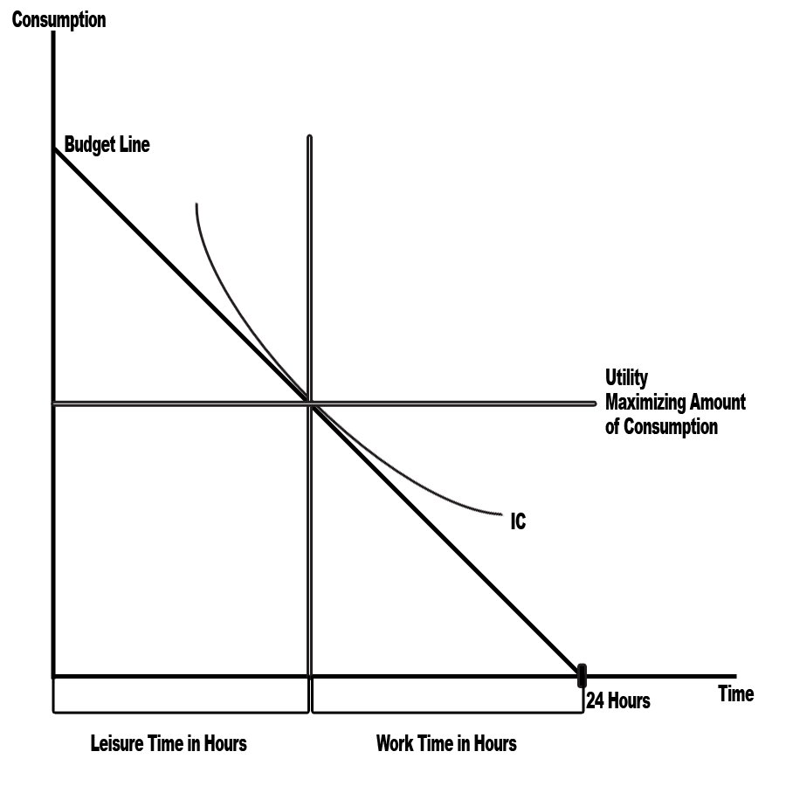
Figure 14

Based on the definitions in McCloskey (1982), Figure 14 is a graph laying out the problem involving the tradeoff between consumption and leisure. In this type of problem, both consumption and leisure are considered to be normal goods.
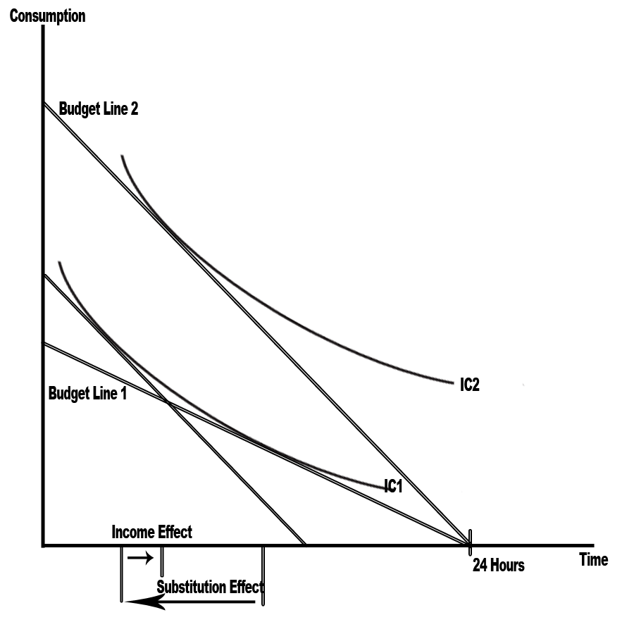
Figure 15

Based on the definitions in McCloskey (1982), Figure 15 shows the case where the income effect is relatively small, while the substitution effect is large.

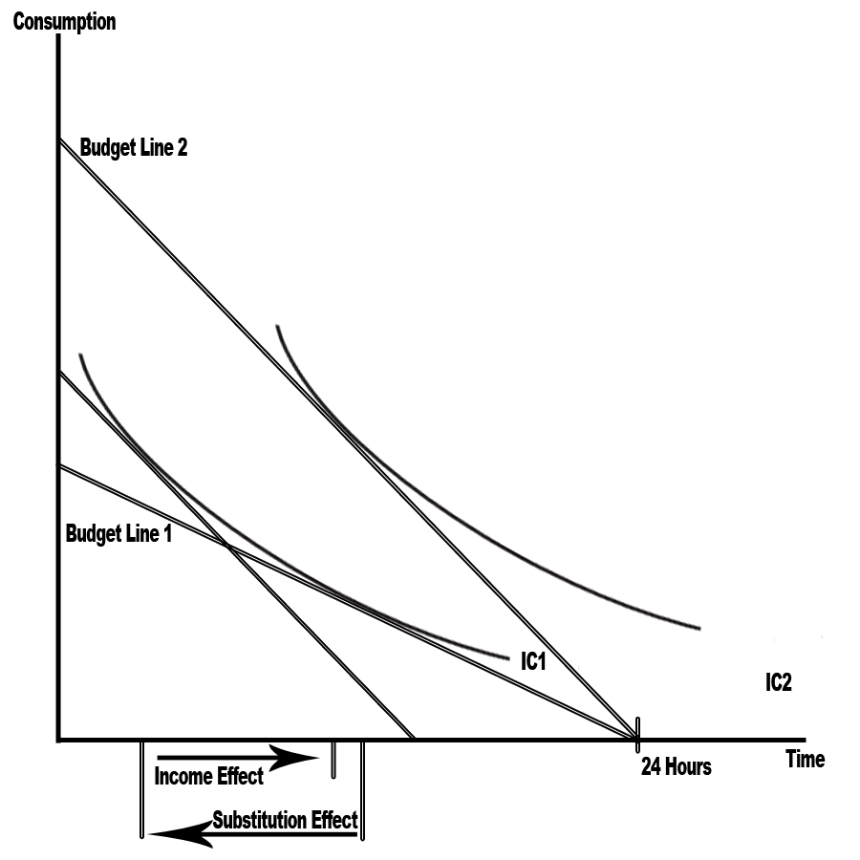
Figure 16

Based on the definitions in McCloskey (1982), Figure 16 shows the case when both the income and substitution effect are large.
Now that it has been established that time versus income is not a good measure of the income effect for media, it should be noted that a better measure of media consumption is to look at the purchase of paid media. By that definition of consumption, one could look at the income elasticity as the change in the number of units sold versus the change in income, all else equal. In the case of magazines, it would be the ceteris paribus change in circulation versus the change in the subscriber income levels. One would imagine that magazines would represent a fairly small portion of people’s incomes, and, as a result, the measured income effect would be relatively small. There will be statistical work later in the paper dealing with this very problem.
At this point, it should be noted that out of all of the things that are included in the Slutsky equation only the price elasticity of demand, the income elasticity and the share of the person’s income endowment are things that can be measured. From McCloskey (1982), the substitution effect is something that depends on a person’s particular utility function, which is unknown. But the substitution effect can be found as a residual from all of the known variables (i.e., E_{s}= E_{d}-sE_{I}).
Also, since the elasticities are being measured across the industry as a whole, there are a few other things to consider. The elasticity of demand for an industry as a whole tends to be smaller, while individual brands within that industry have relatively high elasticities. For example, this is something that is seen in an industry like the cigarette industry. From McCloskey (1982), the elasticity of demand for an industry like cigarettes is relatively low, while the elasticity of demand for a given brand of cigarettes is relatively high. This is because there are more substitutes for an individual brand, while there are very few substitutes for an entire industry. Thus, it wouldn’t be that surprising to see a relatively small price elasticity of demand for the magazine industry as a whole. There will be statistical work later in the paper dealing with this very problem with magazines.
Now, it could be said that the cigarette industry and the magazine industry are worlds apart, so there aren’t any ready comparisons. But the two industries aren’t that far away from each other. Both categories of goods are readily recognizable from the outside. The quality of the two goods is judged based on the quality of what’s on the inside and the experience that it creates. For the cigarette industry, the stuff on the inside is tobacco. For the magazine industry, the stuff on the inside is content, which is pictures and words. Also, both industries try to provide consumers with the same experience over and over again to get you addicted to their product.

CHAPTER III
NECESSARY MATH

SECTION I. UNCONSTRAINED OPTIMIZATION (SORT OF)
Other than the numerous drawings that can be seen in McCloskey (1982), Stigler (1987) and numerous other textbooks, it is important to note first that the drawing of the demand, marginal revenue and marginal cost curves shown in the first chapter wasn’t conjured completely out of thin air.
From McCloskey (1982), Stigler (1987), Dixit (1990), Varian (1992), Hicks (1939), and Mas-Colell (1995), total revenue from the sale of a good is equal to price times quantity. This is commonly graphed with q on the horizontal axis and p on the vertical axis. As a result, total revenue will be represented as TR(q)=qp(q), where q is quantity and p(q) represents the change in price as quantity changes. Marginal revenue can be derived from this equation as the derivative of total revenue with respect to q.
TR(q)=qp(q)
MR(q) = ∂TR(q)/∂q= p(q) + q∂p(q)/∂q
Based on the above equation, it is apparent marginal revenue equals demand when q is equal to 0. This means that the two equations share the same price intercept in the case of a straight-line demand curve.
MR(0) = p(0) + (0)∂p(0)/∂q
MR(0) = p(0)
To find the slope of marginal revenue, all one has to do is take the derivative of marginal revenue with respect to q.
∂MR(q)/∂q=∂²TR(q)/∂q²= ∂p(q)/∂q + ∂p(q)/∂q + q∂²p(q)/∂q²
∂MR(q)/∂q=∂²TR(q)/∂q²= 2∂p(q)/∂q + q∂²p(q)/∂q²
In the case of a straight-line demand curve, the second derivative of demand with respect to q is equal to 0. This means that, in the case of a straight-line demand curve, the slope of the marginal revenue curve is twice that of the demand curve. Thus, in the straight-line representation, the marginal revenue curve crosses the x-axis twice as fast as the demand curve. This means that the point where marginal revenue equals 0 is at the midpoint of the demand curve. At this point, goods are considered unit elastic. To the left of this point, marginal revenue is greater than 0 and goods are considered elastic. To the right of this point, marginal revenue is less than 0 and goods are considered inelastic.
It is worth noting that, in addition to calculating the slope of the marginal revenue curve via the second derivative, the slope of the marginal revenue curve can be inferred from the structure of the equation.
MR(q) = p(q) + q∂p(q)/∂q
MR(q) = p(q)(1 + (q/ p(q)) (∂p(q)/∂q) )
MR(q) = p(q)(1 + (1/E_{D}) )
In this manner, the slope of the marginal revenue curve is related to the elasticity of demand.
Now that revenue has been introduced, it is now time to take a look at cost. From McCloskey (1982), Stigler (1987), Dixit (1990), Varian (1992), Hicks (1939), and Mas-Colell (1995), the marginal cost curve for the production of magazines or any other good is a function of the cost for printing each additional unit. Each individual publication has knowledge of its own cost curve for the production of each magazine, but it is hard to estimate the cost curve for the industry relative to the production of each additional magazine, because price sensitivity is on the part of the consumer.
With this in mind, it should be noted that the marginal cost curve as drawn in the first chapter is inferred from what is known about economic theory and the magazine business. While sunk or first-copy costs like staffing the office and producing the content might be the largest component of overall costs, printing the magazines makes up the bulk of a magazine company’s marginal cost. Generally, as the number of magazine orders grows in size, the cost for each additional copy goes down to a point. This shows up in the declining average variable cost, which is the number of copies produced and sold divided by the total cost of the printing run. Past a certain point, the marginal cost of each additional copy goes up. At some point on its the upward slope, the marginal cost curve intersects with the average cost curve at the point where average costs are the lowest. Assuming there is a portion of the average cost curve that goes underneath the demand curve, businesses are going to at least produce up to the point where marginal revenue intersects with marginal cost. Otherwise, they are not maximizing profits. In the case of a perfectly competitive market the slope of marginal revenue curve is either 0 or downward sloping. In the case where the slope of the marginal revenue curve is 0, the slope of the marginal cost curve still remains positive at the point of intersection. This is why the elasticity of supply has to be positive. Finally, if there is no portion of the cost curve under the marginal revenue curve, then the magazine will go out of business. All of this is from theory in texts like McCloskey (1982), Stigler (1987), Dixit (1990), Varian (1992), Hicks (1939), and Mas-Colell (1995).
Until now, everything has been expressed as a function of quantity for the purposes of graphing. This is a result of the heavy influence from French economists like Antoine Augustin Cournot. Sometimes it is useful to think about things the other way around where.
R(P) = P Q(P)
And profit is
π(P, W)=R(P) - C(W)
This is the form more heavily used in Dixit (1990), Varian (1992), and Mas-Colell (1995).
From Varian (1992), it is known that the above function has some interesting properties that have important implications with profit now a function of price. One of these properties is that the profit function is homogeneous of degree one. This has the side effect that the revenue and cost functions are also monotonic of degree one.
π(tP, tW)=R(tP) - C(tW) = tR(P) - tC(W)= tπ(P, W)
The significance of the fact that profit, revenue and cost functions are monotonic of degree one is that they are all expressed in real terms. As a result, changes in the price of one good are implicitly changes in price relative to all other goods, and changes in the quantity of one good are implicitly changes in quantity relative to other goods.
From Dixit (1990), Varian (1992), and Mas-Colell (1995), this comes out more clearly, when you think about what is going on inside the profit function. First, P and W are both vertical vectors of prices. Both the revenue and cost function are inner products between the vertical vector of prices and the vertical vector of quantities demanded of each good. As a result, P and W can be combined into one vector of prices with all of the prices in W negated, so that the profit function can be rewritten as
π(P)=PX
with PX being a dot product between the vertical vector of prices and the vertical vector of quantities demanded. The mapping to the above function is displayed below.
π(P)=P⋅X=P^{T}X=P_{p}^{T}X_{R}-P_{w}^{T}X_{c}=R(P_{p})-C(P_{w})
From Varian (1992), defining the profit function as a dot product has the advantage that quantity is projected onto price such that taking these next two identities where |X| and |P| represent the norm of X and P or their distance from the origin.
|X|=√(XX)
|P|=√(PP)
and applying the Pythagorean theorem
|tX|²+|P-tX|²=|P|²
t²XX+(P-tX) (P-tX) = PP
t²XX+PP-2tPX+t²XX = PP
2t²XX+PP-2tPX = PP
2t²XX = PP-PP+2tPX
2t²XX = 2tPX
tXX = PX
t=PX/XX
Using the variable t, X can be expressed by its distance from P. This has the effect that both vectors are now pointed in the same direction, but the resulting vector is only PX/XX in length. So, everything is being expressed in relative terms. This is formally called projecting X onto P.
From Dixit (1990), Varian (1992), and Mas-Colell (1995), the profit function isn’t the only function using the dot product. There are other functions that use it too. Many of these functions have equations expressed in the form E(P)=PX, C(ϖ)=ϖX or m=PX. These equations are using shorthand to represent the dot product between two column vectors without explicitly showing it, because it is already known that the output of those equations is a scalar. The forms of P, ϖ and X are listed below.

ω₁
…..
ω_{n}
x₁
…..
x_{n}
P₁
…..
p_{n}
P = ϖ= X=

The equations are written
m= ⋅
P₁
…..
p_{n}
x₁
…..
x_{n}

m= Σ_{i=0 to n} p_{i} x_{i}

P₁
…..
p_{n}
E(P, u)= ⋅
X₁
…..
x_{n}

E(P, u)= Σ_{i=0 to n} p_{i} x_{i}

C(ϖ)= ⋅
ω₁
…..
ω_{n}
x₁
…..
x_{n}

C(ϖ)= Σ_{i=0 to n} ω_{i} x_{i}

Many of the above equations will be referenced in a little bit, and it is worth knowing explicitly what is happening.

SECTION II. OPTIMIZING UNDER CONSTRAINTS
In real life, people make decisions under constraints. After all, the income effect and the substitution effect mentioned in the previous chapter make sense only if consumers are limited in the amount of money that they can make in a given period of time or the amount of time they have to spend with the stuff they have purchased. With this in mind, it is a good idea to set up a framework for analyzing decisions made under constraints. This is primarily done using the Lagrange equation
L(Χ, Λ)=F(Χ)+Λ[C-G(Χ)]
where F(X) is the equation being maximized. This is a form commonly referenced in Dixit (1990), Varian (1992), and Mas-Colell (1995). The following form follows from those texts. The function, as a whole, is a scalar, which means that when it takes on one or more values it returns a single value. F(X)’s matrix of partial derivatives will be taken to be a row vector, since its vector input X is a column vector. C-G(Χ) represents the column vector of m constraints. Λ represents the row vector of m Lagrange multipliers. Λ times C-G(Χ) is an inner product, which means that the result is a scalar. This means that the result of the Lagrange equation is a scalar.
All of these equations use the following matrix notation.
x₁
….
x_{n}
Χ=

Λ =
Λ ₁ | ….. | λ_{m}

C =
c₁
…..
c_{m}

g₁(X)
…..
g_{m}(X)
G(Χ)=

where each g_{i}(X) is a scalar function that it takes one or more values and returns a single value. Its matrix of partial derivatives will be taken to be a row vector of partial derivatives, since its vector input X is a column vector.
Thus,
L(Λ, X)=F(Χ)+Λ[C-G(Χ)]
L(Λ, X)=F(x₁, …..,x_{n})+ [ - ]
λ ₁ | ….. | λ_{m}
g₁(x₁, ...,x_{n})
…..
g_{m}(x₁, ...,x_{n})
c₁
…..
c_{m}

L(Λ, X)=F(x₁, …..,x_{n})+
λ ₁ | ….. | λ_{m}
c₁-g₁( x₁, ...,x_{n} )
…..
c_{m}-g_{m}( x₁, ...,x_{n} )

L(Λ, X)=F(x₁, …..,x_{n})+ Σ_{i=0 to m} λ_{i} (c_{i}-g_{i}(x₁, ...,x_{n}))
Thus,
L(Λ, X)=L(λ₁, ….., λ_{m}, x₁, …..,x_{n})= F(x₁, …..,x_{n})+ Σ_{i=0 to m} λ_{i} (c_{i}-g_{i}(x₁, ...,x_{n}))

From Dixit (1990), Varian (1992), and Mas-Colell (1995), the first order condition is that DL(Λ, X)=0
From the above definition of the Lagrange equation, the following holds
DL(Λ, X)= =
∂L(Λ, X)/∂λ₁
…..
∂L(Λ, X)/∂λ_{m}
∂L(Λ, X)/∂x₁
…..
∂L(Λ, X)/∂x_{n}
c₁-g₁(X)
c_{m}-g_{m}(X)
∂F(X)/∂x₁- Σ_{i=0 to m} λ_{i}∂g_{i}(X)/∂x₁
∂F(X)/∂x_{n}- Σ_{i=0 to m} λ_{i}∂g_{i}(X)/∂x_{n}

From Varian (1992), the Hessian matrix of a Lagrange equation is
H = D²L(X)=
∂²L(Λ,X)/∂x₁² | ….. | ∂²L(Λ,X)/∂x₁x_{n}
….. | ….. | …..
∂²L(Λ,X)/∂x_{n}x₁ | ….. | ∂²L(Λ,X)/∂x_{n}²

H = D²L(X)=
∂²F(X)/∂²x₁ - Σ_{i=0 to m} λ_{i}∂²g_{i}(X)/∂ ²x₁ | ….. | ∂²F(X)/∂x₁x_{n} - Σ_{i=0 to m} λ_{i}∂²g_{i}(X)/∂x₁x_{n}
….. | ….. | …..
∂²F(X)/∂x_{n}x₁ - Σ_{i=0 to m} λ_{i}∂²g_{i}(X)/∂x_{n}x₁ | ….. | ∂²F(X)/∂x_{n}² - Σ_{i=0 to m} λ_{i}∂²g_{i}(X)/∂x_{n}²

Notice, that the Hessian matrix is always square and of dimension n by n.
From Varian (1992), the second order condition of the Lagrange equation for maximization problems requires that the Hessian matrix be negative semidefinite subject to a linear constraint, which means that
h^{t}D²L(X)h<=0 for all h satisfying Dg(X)h=0
One of these will be worked in the example problem.
From Varian (1992), the second order condition of the Lagrange equation for minimization problems requires that the Hessian matrix is positive semidefinite subject to a linear constraint.
h^{t}D²L(X)h>=0 for all h satisfying Dg(X)h=0
One of these will be worked in the example problem.
From Varian (1992), the second order condition of a Lagrange equation can also, in the case of a regular local maximum, be that (-1) ^{m+n-1}det(D²L(Λ, X))<0, where m is the number of elements in Λ and n is the number of elements in X.
D²L(Λ, X)=
∂²L(Λ,X)/∂λ₁² | ….. | ∂²L(Λ,X)/∂λ₁λ_{m} | ∂²L(Λ,X)/∂λ₁x₁ | ….. | ∂²L(Λ,X)/∂λ₁x_{n}
….. | ….. | ….. | ….. | ….. | …..
∂²L(Λ,X)/∂λ_{m}λ₁ | ….. | ∂²L(Λ,X)/∂λ_{m}² | ∂²L(Λ,X)/∂λ_{m}x₁ | ….. | ∂²L(Λ,X)/∂λ_{m}x_{n}
∂²L(Λ,X)/∂x₁λ₁ | ….. | ∂²L(Λ,X)/∂x₁λ_{m} | ∂²L(Λ,X)/∂x₁² | ….. | ∂²L(Λ,X)/∂x₁x_{n}
….. | ….. | ….. | ….. | ….. | …..
∂²L(Λ,X)/∂x_{n}λ₁ | ….. | ∂²L(Λ,X)/∂x_{n}λ_{m} | ∂²L(Λ,X)/∂x_{n}x₁ | ….. | ∂²L(Λ,X)/∂x_{n}²

D²L(Λ, X)=
0 | ….. | 0 | ∂g₁(X)/∂x₁ | ….. | ∂g₁(X)/∂x_{n}
….. | ….. | ….. | ….. | ….. | …..
0 | ….. | 0 | ∂g_{m}(X)/∂x₁ | ….. | ∂g_{m}(X)/∂x_{n}
∂g₁(X)/∂x₁ | ….. | ∂g_{m}(X)/∂x₁ | ∂²F(X)/∂²x₁ - Σ_{i=0 to m} λ_{i}∂²g_{i}(X)/∂ ²x₁ | ….. | ∂²F(X)/∂x₁x_{n} - Σ_{i=0 to m} λ_{i}∂²g_{i}(X)/∂x₁x_{n}
….. | ….. | ….. | ….. | ….. | …..
∂g₁(X)/∂x_{n} | ….. | ∂g_{m}(X)/∂x_{n} | ∂²F(X)/∂x_{n}x₁ - Σ_{i=0 to m} λ_{i}∂²g_{i}(X)/∂x_{n}x₁ | ….. | ∂²F(X)/∂x_{n}² - Σ_{i=0 to m} λ_{i}∂²g_{i}(X)/∂x_{n}²

It would be impossible to solve the determinant of the generic matrix above without concrete values for m and n, but the general form for solving the determinate is as follows for a three-dimensional matrix.

A=
A₁₁ | a₁₂ | a₁₃
A₂₁ | a₂₂ | a₂₃
A₃₁ | a₃₂ | a₃₃

det(A)= a₁₁ det( ) - a₁₂ det( )
a₂₂ | a₂₃
a₃₂ | a₃₃
a₂₁ | a₂₃
a₃₁ | a₃₃

+ a₁₃ det( )
A₂₁ | a₂₂
A₃₁ | a₃₂

det(A)= a₁₁ (a₂₂ a₃₃- a₂₃ a₃₂) - a₁₂ (a₂₁ a₃₃- a₂₃ a₃₁) + a₁₃ (a₂₁ a₃₂- a₂₂ a₃₁)

Now that the basics of the Lagrange equation have been laid out and notational issues have been clarified, it is time to define utility maximization and cost minimization, and to list out the assumptions that go with each type of problem. The problem forms can be found in Varian (1992).

Utility maximization is
v(P, m*)= max u(X) such that PX<=m*

Cost minimization is
e(P, u*)= max u(X) such that u(X)>=u*

From Varian (1992), there are some useful properties that come out of utility maximization and cost minimization that will be listed below. In these identities, the Hicksian demand (the demand curve derived from cost minimization) will be denoted by x_{i}^{h}(P, u*) with a superscript h. The Marshallian demand (the demand curve derived from utility maximization) will be denoted by x_{i}^{m}(P, m*) with a superscript m.

For utility maximization,
v(P, m) is the indirect utility function.
v(P, m) is non increasing in P, so if P>=Q, then v(P, m)<= v(Q, m).
v(P, m) is non increasing in m, so if m>=n, then v(P, m)<= v(Q, n).
v(P, m) is homogeneous of degree 0 in (P, m).
v(P, m) is quasiconvex in P, which means that {P: v(P, m*)<=k} is a convex set for all k.
v(P, m*) is continuous at all p>>0, m>0.
∂v(P, m*)/∂m = λ(P, m*) , which is the marginal utility of income.
x_{i}^{m}(P, m*)=[∂v(P, m*)/∂p_{i}]/[∂v(P, m*)/∂m] by Roy’s identity if X^{m}(P, m*) is the Marshallian demand function. The identities used to prove Roy’s identity are listed out under the header “Identities that relate cost minimization to utility maximization.”
∂v(P, m*)/∂p_{i}= x_{i}^{m}(P, m*) λ(P, m*) follows from Roy’s identity.

For cost minimization,
e(P, u) is the expenditure function.
e(P, u) is nondecreasing in P, so if P>=Q, then e(P, u)>=e(Q, u).
e(P, u) is homogeneous of degree one in P.
e(P, u) is concave in P.
e(P, u) is continuous in P for P>>0.
e(P, u) is continuous in P for P>>0.
∂e(P, u)/∂p_{i}= x_{i}^{h}(P, u) if x(P, u) is the expenditure minimizing bundle at u and P, assuming the derivative exists and that p_{i}>0.
∂e(P, u)/∂u= λ(P, u)

Identities that relate cost minimization to utility maximization
e(P, v(P, m))=m where the minimum expenditure necessary to reach v(P, m) is m
v(P, e(P, u))=u where the maximum utility from e(P, u) is u.
x_{i}^{m}(P, m)= x_{i}^{h}(P, v(P, m)), where x_{i}^{m}(P, m) is the Marshallian demand at income m, and x_{i}^{h}(P, v(P, m)) is the Hicksian demand at utility v(P, m).
x_{i}^{h}(P, u)= x_{i}^{m}(P, e(P, u)), where x_{i}^{h}(P, u) is the Hicksian demand at utility u, and x_{i}^{m}(P, e(P, u)) is the Marshallian demand at income e(P, u).

In this notation, the Slutsky equation written in the following form
∂x_{j}^{m}(P, m)/∂p_{i}= ∂x_{j}^{h}(P, u)/∂p_{i} - (∂x_{j}^{m}(P, m)/∂m) (x_{i}^{m}(P, e(P, u))
and can be derived from the above identities as follows.
x_{j}^{h}(P, u)= x_{j}^{m}(P, e(P, u))
∂x_{j}^{h}(P, u)/∂p_{i}= (∂x_{j}^{m}(P, m)/∂p_{i})+(∂x_{j}^{m}(P, m)/∂m)( ∂e(P, u)/∂p_{i})
∂x_{j}^{h}(P, u)/∂p_{i}= (∂x_{j}^{m}(P, m)/∂p_{i})+(∂x_{j}^{m}(P, m)/∂m)( x_{i}^{h}(P, u))
∂x_{j}^{h}(P, u)/∂p_{i}= (∂x_{j}^{m}(P, m)/∂p_{i})+(∂x_{j}^{m}(P, m)/∂m)( x_{i}^{m}(P, e(P, u))
∂x_{j}^{m}(P, m)/∂p_{i}= ∂x_{j}^{h}(P, u)/∂p_{i} - (∂x_{j}^{m}(P, m)/∂m) (x_{i}^{m}(P, e(P, u))
It is important to note that, in the Slutsky equation, ∂x_{j}^{h}(P, u)/∂p_{i} represents the substitution effect, and (∂x_{j}^{m}(P, m)/∂m) x_{i}^{m}(P, e(P, u)) represents the income effect.

Example
It might be worth working an example problem that includes both utility maximization and cost minimization. So, consider the following problem, which is the maximization of a Cobb-Douglas utility function from Dixit (1990).

Maximize v(p_{1,} p₂, m)=u(x_{1,} x₂)= x₁^{α}x₂^{β} with α+β=1, α>0 and β>0 subject to m=PX in a two good world.
L(Λ, X) = F(X)+ Λ[C-G(X)]
L(λ, x_{1,} x₂) = u(x_{1,} x₂)+ λ[m- p₁x₁ - p₂x₂]
L(λ, x_{1,} x₂) = x₁^{α}x₂^{β} + λ[m- p₁x₁ - p₂x₂]
∂L(x₁, x₂, λ)/∂x₁=αx₁^{α-1}x₂^{β} - λp₁=0
∂L(x₁, x₂, λ)/∂x₂=βx₁^{α}x₂^{β-1} - λp₂=0
∂L(x₁, x₂, λ)/∂λ = m- p₁x₁ - p₂x₂=0
Now, it is time to calculate the Hessian matrix. To check that the Hessian matrix is negative semidefinite subject to a linear constraint, which means that
h^{t}D²L(X)h<=0 for all h satisfying Dg(X)h=0
∂²L(Λ,X)/∂x₁² | ∂²L(Λ,X)/∂x₁x₂
∂²L(Λ,X)/∂x₂x₁ | ∂²L(Λ,X)/∂x₂²
H = D²L(X)=

α(α-1)x₁^{α-2}x₂^{β} | αβx₁^{α-1}x₂^{β-1}
αβx₁^{α-1}x₂^{β-1} | β(β-1)x₁^{α}x₂^{β-2}
D²L(X)=

h^{t}D²L(X)h =
α(α-1)x₁^{α-2}x₂^{β} | αβx₁^{α-1}x₂^{β-1}
αβx₁^{α-1}x₂^{β-1} | β(β-1)x₁^{α}x₂^{β-2}
H₁ | h₂
h₁
h₂

h^{t}D²L(X)h =
H₁(α (α-1)x₁^{α-2}x₂^{β}) +h₂(αβx₁^{α-1}x₂^{β-1}) | h₁(αβx₁^{α-1}x₂^{β-1}) +h₂(β(β-1)x₁^{α}x₂^{β-2})
h₁
h₂

h^{t}D²L(X)h= h₁² (α (α-1)x₁^{α-2}x₂^{β}) + h₁h₂(αβx₁^{α-1}x₂^{β-1})
+h₂h₁(αβx₁^{α-1}x₂^{β-1}) +h₂² (β(β-1)x₁^{α}x₂^{β-2})
h^{t}D²L(X)h= h₁² (α (α-1)x₁^{α-2}x₂^{β}) + 2h₁h₂(αβx₁^{α-1}x₂^{β-1}) +h₂² (β(β-1)x₁^{α}x₂^{β-2})
Remember α+β=1, so β=1-α and α=1-β
h^{t}D²L(X)h= h₁² (α (α-1)x₁^{α-2}x₂^{β}) + 2h₁h₂(αβx₁^{α-1}x₂^{β-1}) +h₂² (β(β-1)x₁^{α}x₂^{β-2})
h^{t}D²L(X)h= h₁² (-αβ x₁^{α-2}x₂^{β}) + 2h₁h₂(αβx₁^{α-1}x₂^{β-1}) +h₂² (-αβx₁^{α}x₂^{β-2})
h^{t}D²L(X)h= -αβ x₁^{α}x₂^{β} [h₁² (x₁²) + 2h₁h₂(-x₁x₂) +h₂² (x₂²)]
h^{t}D²L(X)h= -αβ x₁^{α}x₂^{β} [h₁² (x₁²) - 2h₁h₂(x₁x₂) +h₂² (x₂²)]
h^{t}D²L(X)h= -αβ x₁^{α}x₂^{β} (h₁x₁ -h₂x₂) ²
It is known that (h₁x₁ -h₂x₂) ² is greater than 0. Given that x₁ and x₂ are goods that are being consumed and one cannot consume a negative amount of a good, it is known that x₁^{α}x₂^{β} is greater than or equal to 0. Also, α and β greater than 0 means that αβ is greater than 0. This means that
h^{t}D²L(X)h= -αβ x₁^{α}x₂^{β} (h₁x₁ -h₂x₂) ²≅(-)(+)(+)(+)≅ (-)
This means that h^{t}D²L(X)h<=0 and the Lagrange equation is negative semidefinite. thus, satisfying the second order conditions.
∂L(x₁, x₂, λ)/∂x₁=αx₁^{α-1}x₂^{β} - λp₁=0
αx₁^{α-1}x₂^{β} - λp₁=0
αx₁^{α-1}x₂^{β} =λp₁
λ=(αx₁^{α-1}x₂^{β} )/ p₁
∂L(x₁, x₂, λ)/∂x₂=βx₁^{α}x₂^{β-1} - λp₂=0
βx₁^{α}x₂^{β-1} - λp₂=0
βx₁^{α}x₂^{β-1} = λp₂
λ =(βx₁^{α}x₂^{β-1} )/ p₂
Divide λ=(αx₁^{α-1}x₂^{β} )/ p₁ by λ =(βx₁^{α}x₂^{β-1} )/ p₂
λ/λ =[(αx₁^{α-1}x₂^{β})/ p₁]/[(βx₁^{α}x₂^{β-1})/ p₂]
1 =[(αx₁^{α-1}x₂^{β}) p₂]/ [(βx₁^{α}x₂^{β-1})p₁]
1 =(α p₂ x₂)/ (βp₁x₁)
1 = x₂ (α p₂)/ (βp₁x₁)
x₂ = (βp₁x₁)/(αp₂)
∂L(x₁, x₂, λ)/∂λ = m- p₁x₁ - p₂x₂=0
m- p₁x₁ - p₂x₂=0
Plug in x₂ = (βp₁x₁)/(αp₂)
m- p₁x₁ - p₂(βp₁x₁)/(αp₂)=0
m- p₁x₁ - (βp₁x₁)/(α)=0
m= p₁x₁ + (βp₁x₁)/(α)
m= (αp₁x₁)/(α) + (βp₁x₁)/(α)
m= (αp₁x₁ + βp₁x₁)/(α)
m= x₁ p₁ (α + β)/(α)
x₁ = αm/ [p₁ (α + β)]
Plug x₁ = αm/ [p₁ (α + β)] into x₂ = (βp₁x₁)/(αp₂)
x₂ = (βp₁(αm/ [p₁ (α + β)] ) )/(αp₂)
x₂ = ( βαm/ (α + β) )/(αp₂)
x₂ = βαm/[ (αp₂) (α + β) ]
x₂ = βm/[ p₂(α + β) ]
Plug x₁ = αm/ [p₁ (α + β)] and x₂ = βm/[ p₂(α + β) ] into λ=(αx₁^{α-1}x₂^{β} )/ p₁
λ=(α(αm/ [p₁ (α + β)]) ^{α-1}(βm/[ p₂(α + β) ])^{β} )/ p₁
λ=(α(α^{α-1}m^{α-1}/ [p₁^{α-1} (α + β)^{α-1}]) (β^{β}m^{β}/[ p₂^{β} (α + β)^{β}]) )/ p₁
λ=(α^{α}β^{β}m^{α+β-1}/ [p₁^{α-1} p₂^{β} (α + β)^{α+β-1}]) / p₁
λ=(α^{α}β^{β}m^{α+β-1}/ [p₁^{α} p₂^{β} (α + β)^{α+β-1}])
Plug x₁ = αm/ [p₁ (α + β)] and x₂ = βm/[ p₂(α + β) ] into u(x_{1,} x₂)= x₁^{α}x₂^{β} to get the equation for v(p_{1,} p₂, m)
v(p_{1,} p₂, m)= u(x₁(p_{1,} p₂, m), x₂(p_{1,} p₂, m))
v(p_{1,} p₂, m)= (αm/ [p₁ (α + β)])^{α}(βm/[ p₂(α + β) ])^{β}
v(p_{1,} p₂, m)= (α^{α}m^{α}/ [p₁^{α} (α + β)^{α}]) (β^{β}m^{β}/[ p₂^{β} (α + β)^{β}])
v(p_{1,} p₂, m)= (α^{α}β^{β}m^{α+β}/ [p₁^{α} p₂^{β} (α + β)^{α+β}])
v(p_{1,} p₂, m) represents the maximized function. It has several properties in this context.
v(p_{1,} p₂, m)= (α^{α}β^{β}m^{α+β}/ [p₁^{α} p₂^{β} (α + β)^{α+β}])
∂v(p_{1,} p₂, m)/∂p₁= (-α) (α^{α}β^{β}m^{α+β}/ [p₁^{α+1} p₂^{β} (α + β)^{α+β}])
∂v(p_{1,} p₂, m)/∂p₁= (-1) (α^{α+1}β^{β}m^{α+β}/ [p₁^{α+1} p₂^{β} (α + β)^{α+β}])
∂v(p_{1,} p₂, m)/∂p₁= (-1) (αm/ [p₁ (α + β)]) (α^{α}β^{β}m^{α+β-1}/ [p₁^{α} p₂^{β} (α + β)^{α+β-1}])
∂v(p_{1,} p₂, m)/∂p₁= (-1) x₁(p_{1,} p₂, m) λ(p_{1,} p₂, m)
v(p_{1,} p₂, m)= (α^{α}β^{β}m^{α+β}/ [p₁^{α} p₂^{β} (α + β)^{α+β}])
∂v(p_{1,} p₂, m)/∂p₂= (-β) (α^{α}β^{β}m^{α+β}/ [p₁^{α} p₂^{β+1} (α + β)^{α+β}])
∂v(p_{1,} p₂, m)/∂p₂= (-1) (α^{α}β^{β+1}m^{α+β}/ [p₁^{α} p₂^{β+1} (α + β)^{α+β}])
∂v(p_{1,} p₂, m)/∂p₂= (-1) (βm/[ p₂(α + β) ])(α^{α}β^{β}m^{α+β-1}/ [p₁^{α} p₂^{β} (α + β)^{α+β-1}])
∂v(p_{1,} p₂, m)/∂p₂= (-1) x₂(p_{1,} p₂, m) λ(p_{1,} p₂, m)
v(p_{1,} p₂, m)= (α^{α}β^{β}m^{α+β}/ [p₁^{α} p₂^{β} (α + β)^{α+β}])
∂v(p_{1,} p₂, m)/∂m= (α+β) (α^{α}β^{β}m^{α+β-1}/ [p₁^{α} p₂^{β} (α + β)^{α+β}])
∂v(p_{1,} p₂, m)/∂m= (α^{α}β^{β}m^{α+β-1}/ [p₁^{α} p₂^{β} (α + β)^{α+β-1}])
∂v(p_{1,} p₂, m)/∂m= λ(p_{1,} p₂, m)
v(p_{1,} p₂, m)= (α^{α}β^{β}m^{α+β}/ [p₁^{α} p₂^{β} (α + β)^{α+β}])
v(tp₁, tp₂, tm)= (α^{α}β^{β}t^{α+β} m^{α+β}/ [t^{α} p₁^{α} t^{β} p₂^{β} (α + β)^{α+β}])
v(tp₁, tp₂, tm)= (α^{α}β^{β}t^{α+β} m^{α+β}/ [t^{α+β} p₁^{α} p₂^{β} (α + β)^{α+β}])
v(tp₁, tp₂, tm)= (α^{α}β^{β}m^{α+β}/ [p₁^{α} p₂^{β} (α + β)^{α+β}])
v(tp₁, tp₂, tm)= v(p₁, p₂, m),
which is homogenous of degree 0.

v(p_{1,} p₂, m)= (α^{α}β^{β}m^{α+β}/ [p₁^{α} p₂^{β} (α + β)^{α+β}])
x₁(p_{1,} p₂, m) = αm/ [p₁ (α + β)]
x₂(p_{1,} p₂, m) = βm/[ p₂(α + β) ]
λ(p_{1,} p₂, m) =(α^{α}β^{β}m^{α+β-1}/ [p₁^{α} p₂^{β} (α + β)^{α+β-1}])
If you look at exercise 2.1 in Dixit (1990), there is a typo. The value for λ given in the problem is actually the value function. As such, a common problem given to graduate students is find the error in exercise 2.1 and explain.
It is now time to go the other way. Sticking with the same utility function from Dixit (1990), this example will show expenditure maximization.
Maximize e(p_{1,} p₂, u)=p₁ x₁+p₂ x₂ subject to u(x_{1,} x₂)= x₁^{α}x₂^{β} with α+β=1, α>0 and β>0 in a two good world.
L(Λ, X) = F(X)+ Λ[C-G(X)]
L(λ, x_{1,} x₂) = e(p_{1,} p₂, u)+ λ [u- u(x_{1,} x₂)]
L(λ, x_{1,} x₂) = p₁x₁+ p₂x₂+ λ [u- x₁^{α}x₂^{β}]
∂L(λ, x_{1,} x₂)/∂λ = u- x₁^{α}x₂^{β}=0
∂L(λ, x_{1,} x₂)/∂x₁ = p₁ - αλx₁^{α-1}x₂^{β}=0
∂L(λ, x_{1,} x₂)/∂x₂ = p₂ - βλx₁^{α}x₂^{β-1}=0
Now, it is time to calculate the Hessian matrix. To check that the Hessian matrix is positive semidefinite subject to a linear constraint, which means that
h^{t}D²L(X)h>=0 for all h satisfying Dg(X)h=0
∂²L(Λ,X)/∂x₁² | ∂²L(Λ,X)/∂x₁x₂
∂²L(Λ,X)/∂x₂x₁ | ∂²L(Λ,X)/∂x₂²
H = D²L(X)=

D²L(X)=
-α(α-1)λx₁^{α-2}x₂^{β} | -αβλx₁^{α-1}x₂^{β-1}
-αβλx₁^{α-1}x₂^{β-1} | -β(β-1)λx₁^{α}x₂^{β-2}

h^{t}D²L(X)h =
H₁ | h₂
h₁
h₂
-α(α-1)λx₁^{α-2}x₂^{β} | -αβλx₁^{α-1}x₂^{β-1}
-αβλx₁^{α-1}x₂^{β-1} | -β(β-1)λx₁^{α}x₂^{β-2}

h^{t}D²L(X)h =
-h₁ α(α-1)λx₁^{α-2}x₂^{β}-h₂αβλx₁^{α-1}x₂^{β-1} | -h₁αβλx₁^{α-1}x₂^{β-1}-h₂β(β-1)λx₁^{α}x₂^{β-2}
h₁
h₂

h^{t}D²L(X)h = h₁ (-h₁ α(α-1)λx₁^{α-2}x₂^{β}-h₂αβλx₁^{α-1}x₂^{β-1})
h₂ ( -h₁αβλx₁^{α-1}x₂^{β-1}-h₂β(β-1)λx₁^{α}x₂^{β-2})
h^{t}D²L(X)h = -h₁² α(α-1)λx₁^{α-2}x₂^{β}- h₁h₂αβλx₁^{α-1}x₂^{β-1}
-h₁h₂αβλx₁^{α-1}x₂^{β-1}-h₂²β(β-1)λx₁^{α}x₂^{β-2}
h^{t}D²L(X)h = -h₁² α(α-1)λx₁^{α-2}x₂^{β}- 2h₁h₂αβλx₁^{α-1}x₂^{β-1}-h₂²β(β-1)λx₁^{α}x₂^{β-2}
Remember α+β=1, so β=1-α and α=1-β
h^{t}D²L(X)h = -h₁² (-αβ)λx₁^{α-2}x₂^{β}- 2h₁h₂αβλx₁^{α-1}x₂^{β-1}-h₂²(-αβ)λx₁^{α}x₂^{β-2}
h^{t}D²L(X)h = (αβλx₁^{α}x₂^{β}) (h₁²x₁²-2h₁h₂x₁x₂+h₂²x₂²)
h^{t}D²L(X)h = (αβλx₁^{α}x₂^{β})(h₁x₁- h₂x₂)²
It is known that (h₁x₁ -h₂x₂) ² is greater than 0. Given that x₁ and x₂ are goods that are being consumed and one cannot consume a negative amount of a good, it is known that x₁^{α}x₂^{β} is greater than or equal to 0. λ is greater than or equal to 0. Also, α and β greater than 0 means that αβ is greater than 0. This means that
h^{t}D²L(X)h= αβ λx₁^{α}x₂^{β} (h₁x₁ -h₂x₂) ²≅ (+)(+) (+)(+)≅ (+),
implying that h^{t}D²L(X)h>=0 and the Lagrange equation is positive semidefinite, thus satisfying the second order conditions.

∂L(λ, x_{1,} x₂)/∂x₁ = p₁ - αλx₁^{α-1}x₂^{β}=0
p₁ = αλx₁^{α-1}x₂^{β}
∂L(λ, x_{1,} x₂)/∂x₂ = p₂ - βλx₁^{α}x₂^{β-1}=0
p₂ = βλx₁^{α}x₂^{β-1}
Divide p₁ = αλx₁^{α-1}x₂^{β} by p₂ = βλx₁^{α}x₂^{β-1}
p₁/p₂ = (αλx₁^{α-1}x₂^{β})/(βλx₁^{α}x₂^{β-1})
p₁/p₂ = (αx₂)/(βx₁)
x₂=(βp₁x₁)/(αp₂)
Plug x₂=(β p₁x₁)/(αp₂) into u- x₁^{α}x₂^{β}=0
u- x₁^{α}((β p₁x₁)/(αp₂))^{β}=0
u= x₁^{α}((β p₁x₁)/(αp₂))^{β}
u= x₁^{α} x₁^{β} ((β p₁x₁)/(α p₂))^{β}
u= x₁^{α+β} ((β p₁x₁)/(α p₂))^{β}
x₁^{α+β}= u((α p₂)/(β p₁))^{β}
x₁= u ^{1/(α+β)} ((α p₂)/(β p₁))^{β/(α+β)}
Plug x₁= u ^{1/(α+β)} ((α p₂)/(β p₁))^{β/(α+β)} into x₂=(β p₁x₁)/(αp₂)
x₂=(β p₁ (u ^{1/(α+β)} ((α p₂)/(β p₁))^{β/(α+β)}) )/(αp₂)
x₂=(β p₁ (u ^{1/(α+β)} ((α^{β/(α+β)} p₂^{β/(α+β)})/(β p₁^{/(α+β)}β^{β/(α+β)}))) )/(αp₂)
x₂=u ^{1/(α+β)} (α^{(β-α-β)/(α+β)} p₂^{(β-α-β)/(α+β)})/(p₁^{(β-α-β)/(α+β)}β^{(β-α-β)/(α+β)})
x₂=u ^{1/(α+β)} (α^{-α/(α+β)} p₂^{-α/(α+β)})/(p₁^{-α/(α+β)}β^{-α/(α+β)})
x₂=u ^{1/(α+β)} (p₁^{α/(α+β)}β^{α/(α+β)})/(α^{α/(α+β)} p₂^{α/(α+β)})
x₂=u ^{1/(α+β)} ((β p₁)/(α p₂))^{α/(α+β)}
Plug x₁= u ^{1/(α+β)} ((α p₂)/(β p₁))^{β/(α+β)} and x₂=u ^{1/(α+β)} ((β p₁)/(α p₂))^{α/(α+β)}
into p₁ - αλx₁^{α-1}x₂^{β}=0
p₁ - αλ( u ^{1/(α+β)} ((α p₂)/(β p₁))^{β/(α+β)} )^{α-1}(u ^{1/(α+β)} ((β p₁)/(α p₂))^{α/(α+β)} )^{β}=0
p₁ = αλ( u ^{1/(α+β)} ((α p₂)/(β p₁))^{β/(α+β)} )^{α-1}(u ^{1/(α+β)} ((β p₁)/(α p₂))^{α/(α+β)} )^{β}
p₁ = αλ( u ^{(α-1)/(α+β)} ((α p₂)/(β p₁))^{(α-1)β/(α+β)} ) (u ^{β/(α+β)} ((β p₁)/(α p₂)) ^{(αβ)/(α+β)} )
p₁ = αλ( u ^{(α-1)/(α+β)} ((α p₂)/(β p₁))^{(αβ-β)/(α+β)} ) (u ^{β/(α+β)} ((β p₁)/(α p₂)) ^{(αβ)/(α+β)} )
p₁ = αλu ^{(α+β-1)/(α+β)} ((α p₂) ^{(αβ-β)/(α+β)}/(β p₁)^{(αβ-β)/(α+β)}) ) ((β p₁)^{(αβ)/(α+β)}/(α p₂) ^{(αβ)/(α+β)})
p₁ = αλu ^{(α+β-1)/(α+β)} ((α p₂) ^{(αβ-β-αβ)/(α+β)}/(β p₁)^{(αβ-β-αβ)/(α+β)}) )
p₁ = αλu ^{(α+β-1)/(α+β)} ((α p₂) ^{-β/(α+β)}/(β p₁)^{-β/(α+β)}) )
λ=(p₁/α) u ^{(1-α-β)/(α+β)} ((α p₂) ^{β/(α+β)}/(β p₁)^{β/(α+β)}) )
λ=(p₁/α) u ^{(1-α-β)/(α+β)} (α/p₁)^{β/(α+β)} (p₂/β)^{β/(α+β)}
λ= u ^{(1-α-β)/(α+β)} (α/p₁) ^{(β-α-β)/(α+β)} (p₂/β)^{β/(α+β)}
λ= u ^{(1-α-β)/(α+β)} (α/p₁)^{-α/(α+β)} (p₂/β)^{β/(α+β)}
λ= u ^{(1-α-β)/(α+β)} (p₁/α)^{α/(α+β)} (p₂/β)^{β/(α+β)}
Plug x₁= u ^{1/(α+β)} ((α p₂)/(β p₁))^{β/(α+β)} and x₂=u ^{1/(α+β)} ((β p₁)/(α p₂))^{α/(α+β)} into e(p_{1,} p₂, u)=p₁ x₁+p₂ x₂
e(p_{1,} p₂, u)=p₁ u ^{1/(α+β)} ((α p₂)/(β p₁))^{β/(α+β)}+p₂ u ^{1/(α+β)} ((β p₁)/(α p₂))^{α/(α+β)}
e(p_{1,} p₂, u)=p₁ u ^{1/(α+β)} ((α p₂)/(β p₁))^{β/(α+β)}+p₂ u ^{1/(α+β)} ((α p₂)/(β p₁))^{-α/(α+β)}
e(p_{1,} p₂, u)=p₁ u ^{1/(α+β)} ((α p₂)/(β p₁))^{β/(α+β)}[1+(p₂/p₁) ((α p₂)/(β p₁))^{(-α-β)/(α+β)}]
e(p_{1,} p₂, u)=p₁ u ^{1/(α+β)} ((α p₂)/(β p₁))^{β/(α+β)}[1+(p₂/p₁) ((α p₂)/(β p₁))⁻¹]
e(p_{1,} p₂, u)=p₁ u ^{1/(α+β)} ((α p₂)/(β p₁))^{β/(α+β)}[1+(p₂/p₁) ( (β p₁)/(α p₂)) ]
e(p_{1,} p₂, u)=p₁ u ^{1/(α+β)} ((α p₂)/(β p₁))^{β/(α+β)}[1+β/α ]
e(p_{1,} p₂, u)=p₁ u ^{1/(α+β)} ((α p₂)/(β p₁))^{β/(α+β)}[(α+β)/α ]
e(p_{1,} p₂, u)=p₁ p₁^{-β/(α+β)} u ^{1/(α+β)} ((α p₂)/( β))^{β/(α+β)}[(α+β)/α ]
e(p_{1,} p₂, u)= p₁^{(-β+α+β)/(α+β)} u ^{1/(α+β)} ((α p₂)/( β))^{β/(α+β)}[(α+β)/α ]
e(p_{1,} p₂, u)= p₁^{α/(α+β)} u ^{1/(α+β)} ((α p₂)/( β))^{β/(α+β)}[(α+β)/α ]
e(p_{1,} p₂, u) represents the minimized function. It has several properties in that context.
e(p_{1,} p₂, u)= p₁^{α/(α+β)} u ^{1/(α+β)} ((α p₂)/( β))^{β/(α+β)}[(α+β)/α ]
∂e(p_{1,} p₂, u)/∂ p₁= [α/(α+β)]p₁^{(α-α-β)/(α+β)} u ^{1/(α+β)} ((α p₂)/( β))^{β/(α+β)}[(α+β)/α ]
∂e(p_{1,} p₂, u)/∂ p₁= p₁^{(-β)/(α+β)} u ^{1/(α+β)} ((α p₂)/( β))^{β/(α+β)}
∂e(p_{1,} p₂, u)/∂ p₁= u ^{1/(α+β)} ((α p₂)/( β p₁))^{β/(α+β)}
∂e(p_{1,} p₂, u)/∂ p₁= x₁(p_{1,} p₂, u)
e(p_{1,} p₂, u)= p₁^{α/(α+β)} u ^{1/(α+β)} ((α p₂)/( β))^{β/(α+β)}[(α+β)/α ]
∂e(p_{1,} p₂, u)/∂ p₂= [β/(α+β)]p₁^{(α)/(α+β)} u ^{1/(α+β)} p₂ ^{(β-α-β)/(α+β)} ((α)/( β))^{β/(α+β)}[(α+β)/α ]
∂e(p_{1,} p₂, u)/∂ p₂= [β/(α+β)]p₁^{(α)/(α+β)} u ^{1/(α+β)} p₂ ^{-α/(α+β)} ((α)/( β))^{β/(α+β)}[(α+β)/α ]
∂e(p_{1,} p₂, u)/∂ p₂= [β/α]p₁^{(α)/(α+β)} u ^{1/(α+β)} p₂ ^{-α/(α+β)} ((α)/( β))^{β/(α+β)}
∂e(p_{1,} p₂, u)/∂ p₂= [β/α]^{(α+β)/(α+β)}p₁^{(α)/(α+β)} u ^{1/(α+β)} p₂ ^{-α/(α+β)} ((α)/( β))^{β/(α+β)}
∂e(p_{1,} p₂, u)/∂ p₂= [β/α]^{(α)/(α+β)}(p₁/p ₂) ^{(α)/(α+β)} u ^{1/(α+β)}
∂e(p_{1,} p₂, u)/∂ p₂= ((βp₁)/(αp ₂)) ^{(α)/(α+β)} u ^{1/(α+β)}
∂e(p_{1,} p₂, u)/∂ p₂= u ^{1/(α+β)} ((βp₁)/(αp ₂)) ^{(α)/(α+β)}
∂e(p_{1,} p₂, u)/∂ p₂= x₂(p_{1,} p₂, u)
e(p_{1,} p₂, u)= p₁^{α/(α+β)} u ^{1/(α+β)} ((α p₂)/( β))^{β/(α+β)}[(α+β)/α ]
∂e(p_{1,} p₂, u)/∂u=(1/(α+β))p₁^{α/(α+β)} u ^{(1-α-β)/(α+β)} ((α p₂)/( β))^{β/(α+β)}[(α+β)/α ]
∂e(p_{1,} p₂, u)/∂u=(1/α)p₁^{α/(α+β)} u ^{(1-α-β)/(α+β)} ((α p₂)/( β))^{β/(α+β)}
∂e(p_{1,} p₂, u)/∂u=(1/α)p₁^{α/(α+β)} u ^{(1-α-β)/(α+β)} α^{β/(α+β)} (p₂/β)^{β/(α+β)}
∂e(p_{1,} p₂, u)/∂u=p₁^{α/(α+β)} u ^{(1-α-β)/(α+β)} α^{(β-α-β)/(α+β)} (p₂/β)^{β/(α+β)}
∂e(p_{1,} p₂, u)/∂u=p₁^{α/(α+β)} u ^{(1-α-β)/(α+β)} α^{-α/(α+β)} (p₂/β)^{β/(α+β)}
∂e(p_{1,} p₂, u)/∂u=(p₁/α)^{α/(α+β)} u ^{(1-α-β)/(α+β)} (p₂/β)^{β/(α+β)}
∂e(p_{1,} p₂, u)/∂u= u ^{(1-α-β)/(α+β)}(p₁/α)^{α/(α+β)}(p₂/β)^{β/(α+β)}
∂e(p_{1,} p₂, u)/∂u= λ(p_{1,} p₂, u)
e(p_{1,} p₂, u)= p₁^{α/(α+β)} u ^{1/(α+β)} ((α p₂)/( β))^{β/(α+β)}[(α+β)/α ]
e(tp₁, tp₂, u)= t^{α/(α+β)} p₁^{α/(α+β)} u ^{1/(α+β)} ((αt p₂)/( β))^{β/(α+β)}[(α+β)/α ]
e(tp₁, tp₂, u)= t ^{(α)/(α+β)} p₁^{α/(α+β)} u ^{1/(α+β)} t^{β/(α+β)} ((αp₂)/( β))^{β/(α+β)}[(α+β)/α ]
e(tp₁, tp₂, u)= t ^{(α+β)/(α+β)} p₁^{α/(α+β)} u ^{1/(α+β)} ((αp₂)/( β))^{β/(α+β)}[(α+β)/α ]
e(tp₁, tp₂, u)= t p₁^{α/(α+β)} u ^{1/(α+β)} ((αp₂)/( β))^{β/(α+β)}[(α+β)/α ]
e(tp₁, tp₂, u)= t e(p₁, p₂, u)
e(p₁, p₂, u) is homogeneous of degree 1 in P.

e(p_{1,} p₂, u)= p₁^{α/(α+β)} u ^{1/(α+β)} ((α p₂)/( β))^{β/(α+β)}[(α+β)/α ]
x₁(p_{1,} p₂, u)= u ^{1/(α+β)} ((α p₂)/( β p₁))^{β/(α+β)}
x₂(p_{1,} p₂, u)=u ^{1/(α+β)} ((β p₁)/(α p₂))^{α/(α+β)}
λ(p_{1,} p₂, u)= u ^{(1-α-β)/(α+β)} (p₁/α)^{α/(α+β)} (p₂/β)^{β/(α+β)}

The utility maximization results can be rewritten as
v(p_{1,} p₂, m)= (α^{α}β^{β}m^{α+β}/ [p₁^{α} p₂^{β} (α + β)^{α+β}])
x₁^{m}(p_{1,} p₂, m) = αm/ [p₁ (α + β)]
x₂ ^{m}(p_{1,} p₂, m) = βm/[ p₂(α + β) ]
λ ^{m}(p_{1,} p₂, m) =(α^{α}β^{β}m^{α+β-1}/ [p₁^{α} p₂^{β} (α + β)^{α+β-1}])

The cost minimization results can be rewritten as
e(p_{1,} p₂, u)= p₁^{α/(α+β)} u ^{1/(α+β)} ((α p₂)/( β))^{β/(α+β)}[(α+β)/α ]
x₁^{h}(p_{1,} p₂, u)= u ^{1/(α+β)} ((α p₂)/( β p₁))^{β/(α+β)}
x₂^{h}(p_{1,} p₂, u)=u ^{1/(α+β)} ((β p₁)/(α p₂))^{α/(α+β)}
λ^{h}(p_{1,} p₂, u)= u ^{(1-α-β)/(α+β)} (p₁/α)^{α/(α+β)} (p₂/β)^{β/(α+β)}

Slutsky Equation
∂x_{j}^{m}(P, m)/∂p_{i}= ∂x_{j}^{h}(P, u)/∂p_{i} - (∂x_{j}^{m}(P, m)/∂m) (x_{i}^{m}(P, e(P, u))
Now, a solution will be given for one of the Slutsky equations.
∂x₁^{m}(P, m)/∂p₂= ∂x₁^{h}(P, u)/∂p₂ - (∂x₁^{m}(P, m)/∂m) (x₂^{m}(P, e(P, u))
First, solving for the parts of the equation:
x₁^{m}(p_{1,} p₂, m) = αm/ [p₁ (α + β)]
∂x₁^{m}(p_{1,} p₂, m)/∂p₂ = 0
x₁^{h}(p_{1,} p₂, u)= u ^{1/(α+β)} ((α p₂)/( β p₁))^{β/(α+β)}
x₁^{h}(p_{1,} p₂, u)= u ^{1/(α+β)} p₂^{β/(α+β)}(α/( β p₁))^{β/(α+β)}
∂x₁^{h}(p_{1,} p₂, u)/∂p₂= u ^{1/(α+β)} (β/(α+β)) p₂ ^{(β-α-β)/(α+β)} (α/( β p₁))^{β/(α+β)}
∂x₁^{h}(p_{1,} p₂, u)/∂p₂= u ^{1/(α+β)} (β/(α+β)) p₂ ^{(β-α-β)/(α+β)}β^{-β/(α+β)}(α/p₁)^{β/(α+β)}
∂x₁^{h}(p_{1,} p₂, u)/∂p₂= u ^{1/(α+β)} (1/(α+β)) p₂ ^{(β-α-β)/(α+β)}β^{(-β+α+β)/(α+β)}(α/p₁)^{β/(α+β)}
∂x₁^{h}(p_{1,} p₂, u)/∂p₂= u ^{1/(α+β)} (1/(α+β)) p₂ ^{(-α)/(α+β)}β^{(α)/(α+β)}(α/p₁)^{β/(α+β)}
∂x₁^{h}(p_{1,} p₂, u)/∂p₂= u ^{1/(α+β)} (1/(α+β)) (β/p₂) ^{α/(α+β)} (α/p₁)^{β/(α+β)}
x₁^{m}(p_{1,} p₂, m) = αm/ [p₁ (α + β)]
∂x₁^{m}(p_{1,} p₂, m)/∂m = α/ [p₁ (α + β)]
Plug
∂x₁^{m}(p_{1,} p₂, m)/∂p₂ = 0
∂x₁^{h}(p_{1,} p₂, u)/∂p₂= u ^{1/(α+β)} (1/(α+β)) (β/p₂) ^{α/(α+β)} (α/p₁)^{β/(α+β)}
∂x₁^{m}(p_{1,} p₂, m)/∂m = α/ [p₁ (α + β)]
x₂^{h}(p_{1,} p₂, u)=u ^{1/(α+β)} ((β p₁)/(α p₂))^{α/(α+β)}
into the Slutsky equations.
∂x₁^{m}(P, m)/∂p₂= ∂x₁^{h}(P, u)/∂p₂ - (∂x₁^{m}(P, m)/∂m) (x₂^{m}(P, e(P, u))
0=( u ^{1/(α+β)} (1/(α+β)) (β/p₂) ^{α/(α+β)} (α/p₁)^{β/(α+β)})
-(α/ [p₁ (α + β)])( u ^{1/(α+β)} ((β p₁)/(α p₂))^{α/(α+β)})
0= u ^{1/(α+β)} (1/(α+β)) [(β/p₂) ^{α/(α+β)} (α/p₁)^{β/(α+β)}-(α/p₁) ((β p₁)/(α p₂))^{α/(α+β)}]
0= u ^{1/(α+β)} (1/(α+β)) [(β/p₂) ^{α/(α+β)} (α/p₁)^{β/(α+β)}-(α/p₁) (p₁/α )^{α/(α+β)} (β/ p₂)^{α/(α+β)}]
0= u ^{1/(α+β)} (1/(α+β)) [(β/p₂) ^{α/(α+β)} (α/p₁)^{β/(α+β)}- (α/p₁) ^{(α+β-α)/(α+β)} (β/ p₂)^{α/(α+β)}]
0= u ^{1/(α+β)} (1/(α+β)) [(β/p₂) ^{α/(α+β)} (α/p₁)^{β/(α+β)}- (α/p₁) ^{β/(α+β)} (β/ p₂)^{α/(α+β)}]
0= u ^{1/(α+β)} (1/(α+β)) [(β/p₂) ^{α/(α+β)} (α/p₁)^{β/(α+β)}- (β/ p₂)^{α/(α+β)} (α/p₁) ^{β/(α+β)}]
0= u ^{1/(α+β)} (1/(α+β)) [0]
0=0

Using the above framework to study purchases, it is now time to look at a more generic example of why time has to be added as a constraint when you are looking at goods that are provided for free. The income effect in the Slutsky equation is denoted by (∂x_{j}^{m}(P, m)/∂m) (x_{i}^{m}(P, e(P, u)), with prices held constant while income varies. Since this is measured using the Marshallian demand curve, the focus will primarily be on utility maximization.

Maximize u(X) subject to m=PX in a two good world.
L(Λ, X) = F(X)+ Λ[C-G(X)]
L(λ, x_{1,} x₂)=u(x_{1,} x₂) + λ[m- p₁x₁ - p₂x₂]
∂L(x₁, x₂, λ)/∂x₁=∂u(x₁, x₂)/∂ x₁-λp₁=0
∂u(x₁, x₂)/∂x₁-λp₁=0
∂u(x₁, x₂)/∂x₁=λp₁
λ=∂u(x₁, x₂)/∂x₁/p₁
The marginal utility of income is undefined if p₁=0, because a consumer can’t put free goods in the income constraint.
∂L(x₁, x₂, λ)/∂x₂=∂u(x₁, x₂)/∂ x₂-λp₂=0
∂u(x₁, x₂)/∂x₂-λp₂=0
∂u(x₁, x₂)/∂x₂=λp₂
λ=∂u(x₁, x₂)/∂x₂/p₂
The marginal utility of income is undefined if p₂=0, because a consumer can’t put free goods in the income constraint.
∂L(x₁, x₂, λ)/∂λ =m-p₁x₁ - p₂x₂=0
m-p₁x₁ - p₂x₂=0
The utility function is needed in order to solve for the Marshallian demand functions for x₁ and x₂. But the general point of working this problem is to see that one of the requirements for a good to be on the budget constraint is for it to have a price that is greater than zero.
As a result, you have to take into account time as a possible constraint for free goods. One ends up with a model that has to some extent taken into account the trade off between consumption and leisure. The following problem is a basic form of that model. Maximize F(X)=u(X) subject to m= p₁x₁ and 24= x₁+ x₂ in a two good world where x₁ is hours spent working to get money for consumption and x₂ is hours of leisure. In this model, p₁ is considered the wage rate, which is the price of consumption.
L(Λ, X) = F(X)+ Λ[C-G(X)]
L(λ₁, λ₂, x_{1,} x₂)=u(x_{1,} x₂) + λ₁[m- p₁x₁] + λ₂[24- x₁- x₂]
∂L(λ₁, λ₂, x_{1,} x₂)/∂λ₁= m-p₁x₁ = 0
m-p₁x₁ = 0
m=p₁x₁
x₁=m/p₁
∂L(λ₁, λ₂, x_{1,} x₂)/∂λ₂= 24-x₁ -x₂ = 0
24-x₁ -x₂ = 0
Plug in x₁=m/p₁
24- m/p₁ -x₂ = 0
x₂ = 24- m/p₁
∂L(λ₁, λ₂, x_{1,} x₂)/∂x₂= ∂u(x_{1,} x₂)/∂x₂ - λ₂= 0
∂u(x_{1,} x₂)/∂x₂ - λ₂= 0
λ₂=∂u(x_{1,} x₂)/∂x₂
∂L(λ₁, λ₂, x_{1,} x₂)/∂x₁=∂u(x_{1,} x₂)/∂x₁ - λ₁p₁ - λ₂ = 0
∂u(x_{1,} x₂)/∂x₁ - λ₁p₁ - λ₂ = 0
Plug in λ₂=∂u(x_{1,} x₂)/∂x₂
∂u(x_{1,} x₂)/∂x₁ - λ₁(p₁) - ∂u(x_{1,} x₂)/∂x₂ = 0
∂u(x_{1,} x₂)/∂x₁ - p₁λ₁ - ∂u(x_{1,} x₂)/∂x₂ = 0
p₁λ₁=∂u(x_{1,} x₂)/∂x₁ - ∂u(x_{1,} x₂)/∂x₂
λ₁=(∂u(x_{1,} x₂)/∂x₁ - ∂u(x_{1,} x₂)/∂x₂ )/p₁

λ₁=(∂u(x_{1,} x₂)/∂x₁ - ∂u(x_{1,} x₂)/∂x₂ )/p₁
λ₂=∂u(x_{1,} x₂)/∂x₂
x₁=m/p₁
x₂ = 24- m/p₁
As income goes up, so does consumption, holding wages constant, and an increase in income results in a reduction in the consumption of leisure, holding wages constant, because you have to work in order to consume goods.
One issue with all of this is that the amount of time that people have in a given day is fixed. Thus, assuming that you are already operating at an optimal point and there is only one optimal point on the budget line, if you hold wages fixed, there is no possible way for you to increase income that wouldn’t make you worse off than you already are, because you are already at a tangency between the budget line and the indifference curve. The only way to increase income and remain at an optimal point is to also increase the wage rate. Thus, any measure of the change in the income level would also measure a change in the wage rate, which is a relative price of a consumer’s time and consumption. This means that relative prices do not remain fixed as income rises.
If you were to construct a model that accounted for outside income shocks as well as changes in income due to the wage rate, then it would just be a matter of accounting for what percentage of the income increase came from outside income shocks verses the percentage of the increase in income came from an increase in the wage rate. After doing that, you would then run a regression of the percentage change in time spent with media over the percentage change in income, holding the wage rate constant. Even with that level of accounting, it is still a nontrivial problem to determine the percentage of income increases caused by wage increases. There are whole papers in the field of labor economics devoted to this.

CHAPTER IV
REVIEW OF LITERATURE

There is a wealth of other research in terms of pricing models for the media industry outside of magazines. As a result, it is worth taking a look at some of this work.
Blair (1993) looks at the role of advertising sales on the prices of newspapers. In summarizing his findings, he states that the impact of circulation on advertising sales causes publishers to lower the price of the newspaper below marginal cost in order to increase advertising revenue. Among its assumptions is a stable advertising market for the publishing firms and the fact that the newspapers are acting as monopolists.
Given this, you would assume that the gain received from circulation would increase ad sales enough that it would make up for the lost revenue from subscribers, but that is not necessarily true.
Lewis (1995) uses a dataset on price, circulation and various population statistics from 1971 to 1992 to show that the demand for newspapers in one-paper towns is price inelastic. This means that newspapers could raise their prices and see a relatively smaller percentage decrease in circulation. Thus, up to the point where their own-price elasticity of demand equals negative one, total revenue would increase as price went up and total cost would decrease as the circulation fell in response to the price increase. As a result, papers could make more money if they increased the price of their publications up to the point where their elasticity equaled zero. This means that they would have to keep calculating their elasticity of demand as they raised their price to make sure that they didn’t raise their price too much. Lewis (1995) also found that newspapers with larger circulations tended to be less price inelastic than small circulation newspapers. The result of all of this is that newspapers are leaving money on the table by not charging subscribers more for their product. Some would say that they do the same thing with the content they post online, but that may not entirely be the case.
Hsiang (2005) looked at various factors that influence willingness to pay, such as demographic characteristics (gender, age, education and income). The most interesting part of the findings of Hsiang’s paper was that while income was not considered a significant predictor of willingness to pay for online content, the coefficient for the willingness to pay variable did have a negative sign, which the author took as preliminary evidence of online news being an inferior good. The other interesting part of this paper was the association between some of the other demographic characteristics and willingness to pay for content. Age has a negative association with willingness to pay, and newspaper use has a positive association with willingness to pay. The author felt that if online news is an inferior good, then it might not necessarily take away from the print business to give stuff away for free online, so long as the content provider doesn’t cannibalize the entire print product.
Hsiang (2009) revisited the issue of whether or not online news is an inferior good and tried to calculate the income elasticity of demand using the percentage change in time spent with online news verses the percentage change in income. As was argued in the first two chapters of this paper, this line of thought has several problems. So, it is still unknown whether or not online products are bad for print media.
In fact, having the online product and other products competing might help a publisher at the end of the day. Van der Wurff (2005) looked at the business magazine market and used monopolistic and special competition theories in arguing his case that, as concentration rose in a given market, the diversity of the magazines tended to increase, because companies started to create more niche publications that had smaller audiences. In addition to that, the author put forward the idea that these smaller publications were able to garner larger subscription fees and that the subscription fee was an added incentive for the publisher to get involved in niche publishing. To bolster this point, Van der Wurff showed that there was a negative relationship between the price of a publication and its circulation and put forward the notion that in order to increase the circulation and ad revenue the publisher would have to publish a more general interest publication.
That isn’t the only paper to say that greater concentration isn’t necessarily a bad thing. Van Kranenburg (2001) provides an empirical analysis of the newspaper market in the Netherlands, which has the odd case of having government mandated minimum price increases that are established by a meeting of all of the publishers and approved by the government. The paper establishes that in the Netherlands mergers and consolidations of newspapers have the impact of reducing the cost of subscriptions and ad revenue relative to newspapers that haven’t consolidated. Thus consumers are no worse off after a merger than they would have been before, and, in many cases, the consumer is better off than before.
In addition to that, there are even papers suggesting that advertisers are better off under a monopolization of the market. Reimer (1992) uses data from Newspaper Rates and Data to show that there is a positive relationship between the number of newspapers in a town and the costs advertisers have to pay to reach the entire market. He states that as a result advertisers benefit from a more concentrated, rather than a less concentrated newspaper market. In a way this has some elements of Stigler’s study titled The Theory of Information (Stigler 1961), which talked about the value of advertising in getting information out about a particular product or service, something that would go along well with the benefit of concentration.
While Reimer (1992) didn’t mention Stigler (1961), the author did mentioned Stigler’s study, A Theory of Oligopoly (Stigler 1964), which looked at newspaper advertising and the number of newspapers in a city. The regression function used by the author was the same one estimated by Stigler.
Reimer (1992) did note some other authors that had related works in the field of newspaper concentration. Among them was the work by James Rosse on the concentration of newspapers and startup costs, and the author also referenced two Ph.D. dissertations. The first one was written in 1969 by John Henry Landon and is titled An Intra Industry Approach to Measuring the Effects of Competition: The Newspaper Industry. The second one was written in 1970 by G. L. Grotta, Changes in Ownership of Daily Newspaper and Selected Performance Characteristics, 1950-1968: An Investigation of Some Economic Implications of Concentration of Ownership. Grotta (1970) is probably the paper that most resembles what is being done in this thesis in terms of the type of analysis, but its primary target was the newspaper industry.
In addition to this, there is a diverse amount of research in the fields of satellite television and cable TV that deserves some mention.
Albarran (1990) looks at the cable industry in order to determine the level of diversification of companies that offer channels that subscribers have to pay a premium over the basic cable rate to view. The diversification measure that they used is called D. It looks at pretax profit of the various business segments as a percentage of the total pretax revenues and how dependent the organizations are on one unit of the company. In addition to diversification the paper also looks at the notion of resource dependency or how external resources impact an organization.
Calzada (2007) uses a model of the cable television market that attempts to look at the trade off between ad revenue and the price that the cable company charges subscribers for the product. This model views advertising as a negative for television, which is different from the article that looked at advertising in newspapers as a positive. It put forward the view that the addition of advertising makes the product less desirable and thus makes consumers less willing to pay more for it. While this wasn’t a part of the main theme of the paper, one of the interesting insights mentioned is the fact that broadcast channels, which are aired for free, are charged for as a part of a bundle with cable television. You don’t often think about the fact that when you are paying for the whole package that you are also paying for something that is otherwise free.
Chan-Olmsted (1988) deals with the issues that come out of content providers in the cable industry engaging in horizontal mergers with other content providers in the same industry. It deals with the history of various acquisitions and the antitrust issues that came up. Since it was written in 1988, before the advent of the internet and the explosion of content that came with the internet, it looks at things from the point of view that concentration in the cable industry could be bad for consumers. From that perspective, it provides some useful insights into arguments that come up in a less competitive media marketplace.
Clements (2006) looks at 81 of the most carried cable networks and tries to determine what is the most important factor in determining whether or not a cable network is picked up by the cable operator. It found that, among a number of characteristics, the popularity of the channel and the age of the network were the most important. It also found that the capacity of the system and the demand for advertising were also important.
Foley (1992) looks at the stagnation of the revenues that have occurred in the telecommunications industry since the breakup of Ma Bell and tries to suggest possible avenues for growth. It looks at two possibilities for this growth, the information industry and home video distribution via the phone network. It also looks at the cost of setting up the infrastructure for the two systems and attempts to predict what path the telephone companies will follow. The article does provide some insight into the cost structure of the communication industry.
La Rose (1991) looks at the willingness of people to be interested in a pay TV service. It looked at a number of factors, including age, education, income and attitudes towards pay services. It found that age, income and education were inversely related to whether or not someone would be interested in a pay service. It found, not surprisingly, that there was a positive relationship between attitudes about pay TV and the willingness to use it.
Papies (2008) points out that there currently isn’t access to good movies to download legally and that, as a result, people do most of their movie downloading via illegal means. This paper uses the diffusion of innovation theory and the theory of planned behavior to explain the adoption process for new technological innovations with regard to a movie distribution service. Some of the things that are looked at are the attitude of the consumer towards the innovation, the attitudes of others (called the subjective norm in the paper) and whether or not the consumer is capable of doing the desired activity (called perceived behavior control in the paper). These theories rely on indicators that cause the given behavior. In this paper, the author used the theoretical construct to come up with seven different indicators addressing attitude, relative advantage, compatibility, complexity, the subjective norm, perceived behavioral control and innovativeness. The author ran a regression on survey data from a European online movie rental business and used that to back up the idea that consumers are interested in legal ways to download movies online.
Shu-Chu Sarrina (2004) used industrial organization theory, which is built on the idea that the structure of a business directly impacts the quality of the product and/or service, to study the impact competition had on the cable markets that were controlled by one cable company. It looked at the performance of the company based on three areas of subscriber satisfaction, program service, customer service and community service. It was found that for the most part that in program service and community service that the consumer benefited in part or in whole from competition. Due to the nature of the consumer’s interactions with the cable operators, the community service data were not applicable.
Sohn (2005) mainly looked at the role of competition in the satellite broadcasting industry. In the process, it looked at the theory of competition and niche, which says that in any market where the specialties of firms’ technologies overlap, the firms will try to limit intra-industry competition (competition between firms with similar technology) and increase inter-industry competition (competition between firms with different technologies). To support the argument using this theory, the author used the history of the satellite industries in the United States, Japan, England and France. In all of those countries, the satellite operators used mergers to limit intra-industry competition and focused more on inter-industry competition with cable. The author also looked at the level of inter-industry competition and the impact that had on the profitability of the enterprises. In that case, the author found that the firms benefited from inter-industry competition, because the firms that were located in countries where inter-industry competition took place were operating in the black, while those firms operating in countries where inter-industry competition was nonexistent were in the red. It is worth noting that the author should have taken into account the impact that the size of the country could have when looking at the impact of inter industry competition.
Wirth (1989) used household-level data to determine the demand for cable. Some of the research methods that it used were along the lines of diffusion of innovation, because it was seeking out various explanatory data to try to predict whether or not people would be willing to adopt cable.
While the work in the telecommunication and cable industries is important, the literature on newspapers - referenced at the beginning of this chapter - and the economic literature having to do with elasticities - referenced in chapters two and three - had the most influence on this thesis and the models used. There is still a need for more through analysis of magazine pricing decisions and the use of elasticities in media research.

CHAPTER V
STATISTICAL ANALYSIS

SECTION I. DATA PROVENANCE
The data for this thesis have been collected on the number of ad pages in a magazine, the ad rate a magazine charges, the circulation of a magazine, the newsstand price of a magazine, and the average income of magazine readers.
The number of ad pages was collected from the Publishers Information Bureau first quarter 2010 dataset that is administered by the Magazine Publishers Association of America. The sample represents over 85 percent of consumer magazine advertising volume in the United States (MPA 2010), so this represents a good sample of established magazines. With this in mind, the Publisher’s Information Bureau’s list of magazines will serve as the base list of magazines used for this study of the magazine industry. It contains a total of 217 magazines still in circulation. Out of those magazines, 15 are provided as a part of another product, or are otherwise impossible to assign a price. This leaves 202 magazines.
As explained earlier in extensive detail, it is best to stick with publications that have a price, or you end up having to deal with the sticky issues that come with time. Also, the natural logarithm of zero is undefined.
The ad rate and the circulation figures were collected from the Standard Rate and Data Service as of May 2010 with the ad rate being the rate for one full-page color ad displayed one time. The price figures came primarily from SRDS, with the exception of a few titles that did not list their prices on SRDS. The price figures from those titles not on SRDS either came from Ulrich’s Periodical Directory or a hard copy of the magazine found on the newsstands.
The income data for this project is average income and comes from MRI Plus, which is owned by GfK Mediamark Research & Intelligence. Unfortunately, the income data were not available for all titles in the Publisher’s Information Bureau dataset and the MRI Plus dataset contained data for magazines not in the Publisher’s information Bureau dataset. As a result, a distinction will be made between the smaller dataset that includes both the MRI Plus dataset and the Publisher’s Information Bureau data versus the dataset that has the data for the complete list of magazines in the Publisher’s Information Bureau dataset.

SECTION II. REGRESSIONS AND ANALYSIS
All of the regressions in this section are calculated using the standard log-level model for calculating elasticities found in Woolridge (2009). There is also a nice exposition on how this related to derivatives in some lecture notes in Conlon (2008).
The following regressions were run on the smaller combined dataset with
their respective null hypotheses.
ln(circulation)= b₁ln(price)+ b₂ln(income) +b₀
H₀: b₁= b₂=0
ln(circulation)= b₁ln(price)+ b₀
H₀: b₁=0
where b₁ equals the estimated elasticity of demand and b₂ equals the estimated elasticity of income.

Table 1
Table 2
Table 3
The results of ln(circulation)= b₁ln(price)+ b₂ln(income) +b₀ are reported in Table 1 through Table 3. They show that b₁ is not equal to zero and t is greater than 3.174. Thus, it can be said with 99.8 percent confidence that price does have a negative impact on demand for the chosen sample. Holding other variables constant, the coefficient of -0.81 means that a 10 percent increase in price yields an 8.1 percent decrease in demand for the magazines in the sample. The coefficient also means that the magazines in the sample are priced in the inelastic range. Income is not statistically significant predictor of demand, when prices are held constant. As a result, it will be pruned off as one of the variables to look at further. It should be noted that, if you run a regression with ln(circulation)=b₂ln(income)+b₀, you aren’t holding prices constant, so the results from that would be misleading. The same criticism does not apply to ln(circulation)=b₁ln(price)+b₀, since income is not a statistically significant predictor of demand.

Table 4
Table 5
Table 6
The results of ln(circulation)= b₁ln(price)+ b₀ are reported in Table 4 through Table 6. Without accounting for income, b₁ is not equal to zero and t is greater than 3.390. Thus, it can be said with 99.9 percent confidence that price does have a negative impact on the demand for magazines in the chosen sample. The coefficient of -0.89 means that a 10 percent increase in price yields an 8.9 percent decrease in demand for magazines in the sample. The coefficient also means that the magazines in the sample are priced in the inelastic range of demand. Thus, the removal of income led to a better fit.
The following regressions were run on the larger Publisher’s Information Bureau dataset with their respective null hypotheses.
ln(circulation)= b₁ln(price)+b₀
H₀: b₁=0
ln(ad rate)= b₂ln(circulation)+b₀
H₀: b₂=0
ln(ad pages)= b₃ln(ad rate)+b₀
H₀: b₃=0,
where b₁ equals the estimated elasticity of demand, b₂ shows the relationship between circulation and ad rate and b₃ is the estimated elasticity of supply for ads.

Table 7
Table 8
Table 9
The results of ln(circulation)= b₁ln(price)+ b₀ are shown in Table 7 through Table 9. As can be seen, b₁ is not equal to zero and t is greater than 3.390. Thus, it can be said with 99.9 percent confidence that price does have a negative impact on demand for the chosen sample. Furthermore, the coefficient of -1.5 means that a 10 percent increase in price yields a 15 percent decrease in demand for magazines in the sample. The coefficient also means that the magazines in the sample are priced in the elastic range.
Now, one would have expected the coefficient on price for this regression to be greater than negative one and in the inelastic range, similar to the regression on the combined dataset. The reason why this is not the case is that several of the magazines taken out of the dataset when the income data were merged into the Publisher’s Information Bureau dataset had relatively high prices (prices greater than $7). Normally, this would be seen as a good way of reducing tail risk, but with regard to magazines, prices greater than $7 aren’t that uncommon. In fact, over half of all of the magazines launched in the past two years charged more than $7 and some of those by a wide margin Husni (2009) and Husni (2010). So, if anything, this regression may be underestimating how elastic the prices of magazines really are.

Table 10
Table 11
Table 12
The results of ln(ad rate)= b₂ln(circulation)+b₀ are shown in Table 10 thorugh Table 12. The estimated coefficient of b₂ is not equal to zero and t is greater than 3.390 by a large distance. Thus, it can be said with well over 99.9 percent confidence that circulation does have a significant impact on the ad rate. In fact, the adjusted R² means that over 80 percent of the variation in ad rates about the mean is explained by circulation. This could be taken as strong evidence that magazines are price takers in the market for advertising. Furthermore, the coefficient of 0.72 means that a 10 percent increase in circulation yields a 7.2 percent decrease in the demand for magazines in the sample. This implies that there are diminishing returns in terms of increases in ad rates from increases in circulation.

Table 13
Table 14
Table 15
The results of ln(ad pages)= b₃ln(ad rate)+b₀ are shown in Table 13 through Table 15. The coefficient on b₃ is not equal to zero and t is greater than 3.390. Thus, it can be said with 99.9 percent confidence that price does have a positive impact on quantity supplied for the chosen sample. Furthermore, the coefficient of 0.29 means that a 10 percent increase in ad rate yields a 2.9 percent increase in the supply of ads for magazines in the sample. The coefficient also means that the ad pages in the sample are supplied in the inelastic range. When you consider that publishers are trying to balance the desire to make money versus the desire to keep their publications from coming out looking like one giant advertisement for any and every company, this makes sense. Also, there are costs to increasing the supply of advertising such as hiring ad representatives.
CHAPTER VI
CONCLUSION

Based on the statistical results, the answer to RQ₁ is no. If the elasticity of demand for magazines is elastic, it is not a forgone conclusion that magazines aren’t charging enough for their content.
With regards to RQ₂, it was found that income did not have a statistically significant impact on a consumer’s willingness to pay for a magazine. Thus, RQ₃ is unanswerable, since magazines are neither normal or inferior goods.
Based on the statistical results, magazines have their prices set for them based on the circulation that magazines garner. Thus, the answer to RQ₄ is that magazines are price takers in the market for magazine advertising and the advertising market for magazines is competitive, making RQ₆ unanswerable.
The answer to RQ₅ is that magazines do not immediately respond to an increase in the ad rate. This largely is influenced by the possible impact of advertising on future circulation or the costs of sell the additional advertising.
In answer to RQ₇, it was shown in chapter 3 that the elasticity of demand cannot be measured for a free good. Also, as a practical matter, the natural logarithm of zero is undefined and undefined values cannot be used in a regression analysis.
As for RQ₈, it is might be possible to measure the income elasticity for a free good. In response to RQ₉, it requires that the researcher account for the wage rate and any outside income shocks in their model. A lot of times, it is hard to get access to that sort of data without physically measuring the data through an independent survey. Also, there are some jobs that are paid with a salary. In that case, it is hard to measure what the real wage rate is, because the number of hours worked can vary considerably from person to person.
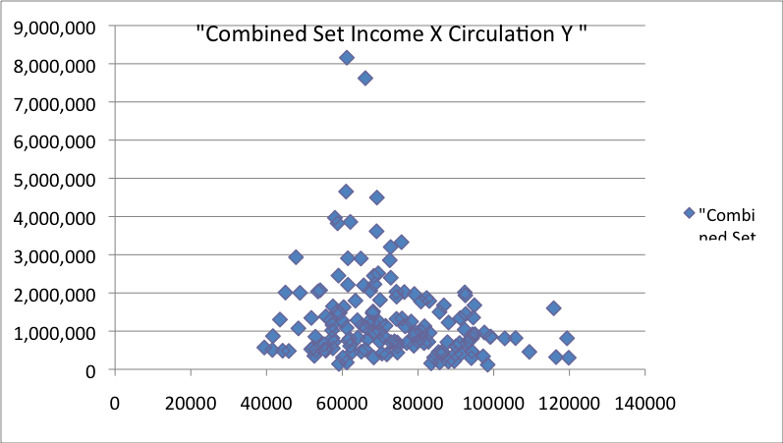
Figure 17

Finally, after looking at all of the data, it is important to keep things in perspective. Figure 17 is a scatter plot diagram of income versus circulation from the combined dataset. Like people, the magazines are scattered roughly in the shape of a bell curve about some mean. Each magazine in that diagram caters to its own unique demographics, so it is difficult to say that some aggregate measure of the medium as a whole are a good measurement for one individual magazine. Every day each individual magazine owner is doing its own measurement of the state of his or her business. Those measurements are probably the best measurements of an individual magazine’s business. It could be that a good decision for one magazine is a terrible decision for any other magazine. The aggregate measurements are just an average of all of the work of the individual magazine owners as they seek to maximize profits.
There are some possibilities for future work to come out of this. It is pretty clear that competition within the magazine industry has changed a good bit over the past century or even the past five years for that matter. While Ole Miss doesn’t save copies of the Standard Rate and Data Service for each quarter, some universities, such as the University of Minnesota, have copies going all the way back to the early 1900’s. It would be interesting to use that data to observe the changes in the market over the last century. It would also be interesting to draw comparisons between the magazine industry and other forms of media over the course of time. In that field, one area that seems to be covered fairly often is the comparison between print and online media. Additionally, there might also be a place for some of this research in areas that deal with antitrust litigation involving media companies.

WORKS CITED

Albarran, A., & Porco, J. (1990). Measuring and Analyzing Diversification of
Corporations Involved in Pay Cable. Journal of Media Economics, 3(2), 3-14. http://search.ebscohost.com

Baine, Lee J. and Max Engelhardt (1992) Introduction to Probability and Mathematical
Statistics. Duxbury Thomson Learning: United States. 1992

Bartle, Robert G. and Donald R. Sherbert. (2000) Introduction to Real Analysis. John
Wiley & Sons: New York. 2000

Bel, G., Calzada, J., & Insa, R. (2007). Access Pricing to a Digital Broadcasting Platform.
Journal of Media Economics, 20(1), 29-53. http://search.ebscohost.com, doi:10.1207/s15327736me2001_2

Blair, Roger D, & Romano, Richard E. (1993). Pricing decisions of the newspaper
monopolist. Southern Economic Journal, 59(4), 721. Retrieved December 6, 2009, from ABI/INFORM Global. (Document ID: 801806).

Chan-Olmsted, S., & Litman, B. (1988). Antitrust and Horizontal Mergers in the Cable
Industry. Journal of Media Economics, 1(2), 3-28. http://search.ebscohost.com

Clements, M., & Abramowitz, A. (2006). Retransmission Consent, Network Ownership,
and the Programming Decisions of Cable Operators. Journal of Media
Economics, 19(4), 221-240. http://search.ebscohost.com, doi:10.1207/s15327736me1904_1

Conlon, John R., (2008) Notes on Applied Mathematical Economics: The Art of
Mathematical Economics Chapters One Through Five. (Unpublished lecture notes from The University of Mississippi)

Dixit, Avinash K. (1990) Optimization in Economic Theory. Oxford University Press:
New York. 1939

Ehrenberg, Ronald G. and Robert S. Smith. (2003) Modern Labor Economics: Theory
and Public Policy. Addison Wesley: New York. 2003

Foley, J. (1992). Economic Factors Underlying Telephone Company Efforts to Enter
Home Video Distribution. Journal of Media Economics, 5(3), 57-68. http://search.ebscohost.com

Goldberg, Richard R. (1976) Methods of Real Analysis. John Wiley & Sons: New York.
1976

Greene, William H. (2008) Econometric Analysis. Pearson Prentice Hall: Upper
Saddle River, NJ. 2008

Grotta, Gerald L., Changes in the Ownership of Daily Newspapers and Selected
Performance Characteristics, 1950-1968: An Investigation of Some Economic Implications of Concentration of Ownership (Unpublished doctoral dissertation, Southern Illinois University, 1970)

Hirshleifer, Jack; Amihai Glazer and David Hirshleifer. (2005) Price Theory and
Applications. Cambridge University Press: New York. 2005

Hicks, John. (1932) The Theory of Wages. The McMillan Company: New York. 1932

Hicks, John. (1939) Value and Capital. Oxford University Press: New York. 1939

Hsiang Iris, C. (2005). Is Online News an Inferior Good? Journalism and Mass
Communication Quarterly, Vol. 86, No. 3 Autumn 2009 594-612.

Hsiang Iris, C. (2005). Willingness to Pay for Online News: An Empirical Study on the
Viability of the Subscription Model. Journal of Media Economics, 18(2), 131-142. http://search.ebscohost.com, doi:10.1207/s15327736me1802_4

Husni, Samir. (2009) Guide to new Magazines. Nautilus Publishing Company: Taylor,
MS 2009

Husni, Samir. (2010) Guide to new Magazines. Nautilus Publishing Company: Taylor,
MS 2010

Husni, Samir. (1998) Launch Your Own Magazine: A Guide for Succeeding in Today’s
Marketplace. Hamblett House Inc.: Nashville, TN 1998

Husni, Samir. (2003) Selling Content: The Step-by-Step Art of Packaging Your Own
Magazine. Kendall/Hunt Publishing Company: Dubuque, IA 2003

Keat, Paul G. and Philip K. Y. Young. (2003) Managerial Economics. Prentice Hall:
Upper Saddle River, NJ. 2003

LaRose, R., & Atkin, D. (1991). Attributes of Movie Distribution Channels and
Consumer Choice. Journal of Media Economics, 4(1), 3-17. http://search.ebscohost.com

Law, Averill M. (2007) Simulation & Modeling Analysis. McGraw Hill: New York. 2007

Leon, Steven J. (2006) Linear Algebra. Pearson Prentice Hall: Upper Saddle River, NJ.
2003

Lewis, R. (1995). Relation Between Newspaper Subscription Price and Circulation,
1971-1992. Journal of Media Economics, 8(1), 25.
http://search.ebscohost.com

Magazine Publishers of America - About PIB
http://magazine.org/ADVERTISING/REVENUE/about.aspx

Magazine Publishers of America - Jan - Mar 2010 vs 2009
http://magazine.org/advertising/revenue/by_mag_title_qtr/pib-1q-2010.aspx

Mas-Colell, Andreu; Michael D. Whinston; and Jerry R. Green. (1995) Microeconomic
Theory. Oxford University Press: New York. 1995

McCloskey, Deirdre N. (1982) The Applied Theory of Price Mcmillan: New York. 1982

Navasky, Victor S. A Matter of Opinion New York: Farrar, Straus and Giroux 2005

Papies, D., & Clement, M. (2008). Adoption of New Movie Distribution Services on
the Internet. Journal of Media Economics, 21(3), 131-157. http://search.ebscohost.com, doi:10.1080/08997760802300530

Reiman, Roy I Could Write a Book. Milwaukee, WI: Grandhaven Group 2005

Reimer, Eric. (1992). The Effects of Monopolization on Newspaper Advertising
Rates. American Economist, 36(1), 65. Retrieved December 6, 2009, from ABI/INFORM Global. (Document ID: 136203).

Rosse, James N., The Evolution of One Newspaper Cities, discussion paper for the
Federal Trade Commission Symposium on Media Concentration: Washington, DC, December 14-15, 1979.

Royden, H. L. (1988) Real Analysis. Pearson Prentice Halle: Upper Saddle River, NJ.
1988

Shu-Chu Sarrina, L. (2004). Market Competition and the Media Performance of
Taiwan's Cable Television Industry. Journal of Media Economics, 17(4), 279-294. http://search.ebscohost.com

Slutsky, Eugen. On the Theory of the Budget of the Consumer. First Published in
Giornale degli Economisti, Vol. LI (1915), pp. 1-26. Reprinted by courtesy of the publisher in Readings in Price Theory by The American Economic Association in 1952. They had the paper translated into English by Olga Ragusa.

Sohn, S. (2005). Interindustry and Intraindustry Competition in Satellite
Broadcasting: A Comparative Case Study on the United States, Japan, England, and France. Journal of Media Economics, 18(3), 167-182. http://search.ebscohost.com, doi:10.1207/s15327736me1803_1

Stewart, James. (2003) Calculus. Thomson Brooks/Cole: Belmont, CA. 2003

Stigler, George J. “A Theory of Oligopoly” Journal of Political Economy, LXXII, 1964.

Stigler, George J. “The Economics of Information” Journal of Political Economy, LXIX,
1961.

Stigler, George J. (1987) The Theory of Price. Macmillan Publishing Company:
New York. 1987

van der Wurff, R. (2005). Business Magazine Market Performance: Magazines for the
Agricultural, Business Services, and Transportation Sectors in the Netherlands. Journal of Media Economics, 18(2), 143-159. http://search.ebscohost.com, doi:10.1207/s15327736me1802_5

van Kranenburg, H. (2001). Economic Effects of Consolidations of Publishers and
Newspapers in The Netherlands. Journal of Media Economics, 14(2), 61-76. http://search.ebscohost.com

Varian, Hal R. (1992) Microeconomic Analysis. W.W. Norton & Company: New York.
1992

Wirth, M., & Bloch, H. (1989). Household--Level Demand for Cable Television: A
Probit Analysis. Journal of Media Economics, 2(2), 21-34. http://search.ebscohost.com

Woolridge, Jeffrey M. (2009) Introduction to Econometrics. South-Western Cengage
Learning: United States. 2009

VITA

Education

Degrees

The University of Mississippi, Oxford, MS
- M.S. Computer and Information Science Expected Graduation Date December 2010
- M.A. Economics Expected Graduation Date December 2010
- M.A. Journalism Expected Graduation Date December 2010
- B.A. Computer and Information Science August 2007
- B.A. Journalism and Economics August 2007
- B.S. Math August 2007

Jackson Academy, Jackson, MS
- High School Diploma May 2002

Work Experience

Independent Contracting
- Self-employment May 2004 to present
This entry encompasses all of the work I have done over the past couple of years for groups and individuals. These are jobs that have used my skills as a writer, a programmer, a designer, a mathematician and an economist. A few of these jobs are referenced below in cases where a formal title exists.

Computer Science

Webmaster
- MrMagazine.com, January 2009 to present

Systems Administration/Teaching
- Mississippi Center for Supercomputer Research September 2007 to May 2008
Helped put together MPI and OpenMP teaching aids and taught classes on MPI, OpenMP, Mathematica and various other software packages or utilities used on MCSR systems.

Programming
- University of Mississippi Office of Research and Sponsored Programs September 2006 to May 2008
Programmed web database applications in Javascript, PHP and MySQL, using the model-view-control design pattern and implementing standard security features to prevent security risks like session stealing.

Journalism

Editor
- MrMagazine.com, August 2008 to January 2009

Managing Editor
- Samir Husni's Guide To New Magazines, March 2009
- MrMagazine.com, January 2009 to present
- MrMagazine.com, June 2006 to January 2007
- Samir Husni's Guide To New Magazines, March 2006

Layout/Art Director
- Journal of Sports Media, March 2006 to March 2008
- Our Voice, the official newsletter of The University of Mississippi Association of Black Journalists, Fall 2005 to Spring 2006
- The Daily Mississippian, July 2005 to May 2006 (News Section)

Senior Editor
- M Magazine, January 2007
- MrMagazine.com, January 2006 to May 2006

Copy Editor
- The Daily Mississippian, April 2006 to August 2006

Assistant Editor
- Samir Husni's Guide To New Magazines, March 2008
- Samir Husni's Guide To New Magazines, March 2007

Writing
- Co-ed Magazine, November 2005
Wrote a feature on the chair of the department of journalism, Samir Husni, the introduction to the college section on Ole Miss, an article about Oxford's social scene and an article about Greek life at Ole Miss. All of the articles appeared in the winter 2005 issue of the magazine.
- The Ole Miss, October 2004 to June 2006
Wrote articles for the student life section, academics section and distinctions section of the yearbook and took photographs.
- The Daily Mississippian, July 2004 to present
Wrote editorials for the opinion section, wrote articles in the arts and life section and took photographs.

Internships
- MSNBC, September 2008
Helped with the network's coverage of the 2008 presidential debate at The University of Mississippi. Tasks included setting up the staging area and the work room; running scripts between the work area and the stage; escorting talent back and forth between press shots; and helping break down all of the gear after the debate was over.
- Athletics Media Relations Student Worker, January 2004 to present
Worked the basketball games for the television crew, passed out stat sheets during the basketball games, put together press books for the basketball games, did the injury reports for the football games, helped set up the home and visiting teams media rooms, took and transcribed quotes from the visiting team and helped set up on game day.

Other Journalism Experience
- Mississippi Scholastic Press Association Summer Workshop, June 2006
Taught people how to use Adobe InDesign and Adobe Photoshop.
- Mississippi Scholastic Press Association Dow Jones Minority Workshop, June 2005
Taught people how to use Adobe InDesign and Adobe Photoshop and designed the template for the workshop's newspaper.
- Assistant to Dr. Samir Husni, chair of the Department of Journalism, May 2005 to present
Wrote articles, did layout for the department newsletter, did layout for presentations, wrote scripts for the department web site and helped maintain department computers. I also helped scan magazine covers and enter data for Samir Husni's Guide to New Magazines.

Other Experience
- Associated Student Body Student Services Committee, April 2004 to April 2005
Responsibilities included gathering information to be used in governing decisions, writing reports, and helping come up with new and innovative ways to serve the students.
- Associated Student Body Communications Committee, April 2003 to April 2004
Responsibilities included writing press releases, gathering information to be used in public relations articles in the press book and coming up with public relations fund raising ideas.
- Warren A. Hood, June 2001 to July 2001
Taught classes geared toward helping campers attain the cooking, pioneering and wilderness survival merit badges.

Awards and Honors
- Member of Upsilon Pi Epsilon, an international honor society for the computing and information disciplines (Inducted Spring 2009). The membership requirements can be found at http://upe.acm.org/member_requirements.htm.
- Member of the UM programming team at the Consortium for Computer Sciences in Colleges: Mid-South Conference at Arkansas Tech University. (Spring 2008)
- Member of the UM programming team at the Consortium for Computer Sciences in Colleges: Mid-South Conference at The University of Louisiana Monroe. (Spring 2007)
- Member of the UM programming team at the Association for Computing Machinery International Collegiate Programming Contest's Southeastern United States Regional (Fall 2006)
- Member of Pi Mu Epsilon, a mathematical honor society (Inducted Fall 2006). The membership requirements can be found at http://www.pme-math.org/organization/whatispme.html
- Placed 2nd in Best Newspaper Page Layout Designer Category at the Southeast Journalism Conference (Spring 2006)
- Selected for the University of Mississippi's Who's Who class of 2005-2006.

Community Involvement
- Alumnus of Sigma Nu Fraternity
- Campus Crusade for Christ August 2002 to present
- Volunteered with Oxford Veteran's Home on January 2003
- Inducted into Order of the Arrow in scouts
- Obtained rank of Eagle scout March 2002
- Volunteered with Mission Mississippi on December 2001
- Volunteered with American Red Cross on August 2001
- Volunteered with Hudspeth on March 2001
- Volunteered with Mississippi Soil and Water Conservation on March 2001
- Volunteered with First Baptist Church Jackson West Park Project on December 2000
- Volunteered with Stew Pot from December 1999 to February 2002
- Volunteered with Baptist Children's Village from June 1999 to July 1999.

Research

Parallel Compression
- I worked on a program called czip for the Cell Broadband Engine. As part of my work, I took a program that had originally been written by Andy Anderson for the Cell Broadband Engine using Cell s.d.k. 1.0. His program used Mark Adler and Jean-loup Gailly's zlib to compress the files and produced output in a series of multiple chunks that was sufficiently gzip compliant that they could be unzipped using gunzip. Using this program as a base, I converted the code to cell s.d.k. 2.1, eliminated the existing 2 gig file size barrier, made it to where the program output the zipped files name in the header (making the file fully gzip compliant), optimized the program to print only one header and trailer for files less than 2 gig and made it to where it broke compressed files into 2 gigabyte chunks for compressed files larger than 2 gigabytes. My work on this was presented at a Mississippi Academy of Sciences conference in the Spring of 2008.
- I am also working on a parallel version of bgzip2 for the Cell Broadband Engine that will be based on the current parallel version of bgzip2.

Web Publishing
- For my senior project in computer science, I worked on a web publishing platform that allowed people to upload a magazine onto a server for others to view and customize by rearranging the content.

Magazines
- I have helped enter data on new magazine launches for Samir Husni's Guide to New Magazines, which is an annually published guide on all of the new magazine launches for each year.

